



Development Standards & Practices Used

Midi-USB Protocol

AES3 Digital Audio Protocol

IEC 60958/AES14 Analog Audio Protocol (¼ inch & XLR analog input/output)

IEEE 315 Specifications for Electrical Design Documentation

IPC-2221 General Specifications for PCB design

IPC-2222 Specifications for PCB design related to high-frequency signal processing

Summary of Requirements

1. Audio Quality & Accuracy
   1. The Final Product should be an accurate emulation of audio passed through a Vacuum-Tube Pre-Amplifier
   2. Final Product should have an easily discernible audio without unwanted distortion or volume/peaking issues
2. Size & Reliability
   1. Final product should be small enough to be moved easily by a single person with little effort, and stored with other instruments
   2. Should remain functional even when exposed to temperature shifts, impacts, minor moisture exposure, etc.
3. Cost
   1. Final product should be significantly cheaper than a similar quality Vacuum Tube/ Vacuum Tube Emulator alternative

Applicable Courses from Iowa State University Curriculum

List all Iowa State University courses whose contents were applicable to your project.

* EE 230
* EE 330
* EE 224
* EE 324
* CprE 281
* Com S 309
* CprE 288
* Music 224

New Skills/Knowledge acquired that was not taught in courses

Gitlab management

Audio processing

Mathematical Extrapolation

Table of Contents

1 Team, Problem Statement, Requirements, and Engineering Standards 5

1.1 Team Members 5

1.2 Required Skill Sets for Your Project 5

(if feasible – tie them to the requirements) 5

1.3 Skill Sets covered by the Team 5

(for each skill, state which team member(s) cover it) 5

1.4 Project Management Style Adopted by the team 5

1.5 Initial Project Management Roles 5

1.6 Problem Statement 5

1.7 Requirements & Constraints 5

1.8 Engineering Standards 5

1.9 Intended Users and Uses 6

2 Project Plan 6

2.1 Task Decomposition 6

2.2 Project Management/Tracking Procedures 6

2.3 Project Proposed Milestones, Metrics, and Evaluation Criteria 6

2.4 Project Timeline/Schedule 7

2.5 Risks And Risk Management/Mitigation 7

2.6 Personnel Effort Requirements 7

2.7 Other Resource Requirements 7

4 Design 8

4.1 Design Content 8

4.2 Design Complexity 8

4.3 Modern Engineering Tools 8

4.4 Design Context 8

4.5 Prior Work/Solutions 9

4.6 Design Decisions 9

4.7 Proposed Design 9

4.7.1 Design 0 (Initial Design) 10

Design Visual and Description 10

Functionality 10

4.7.2 Design 1 (Design Iteration) 10

Design Visual and Description 10

4.8 Technology Considerations 10

4.9 Design Analysis 10

5 Testing 11

5.1 Unit Testing 11

5.2 Interface Testing 11

5.3 Integration Testing 11

5.4 System Testing 11

5.5 Regression Testing 11

5.6 Acceptance Testing 11

5.7 Security Testing (if applicable) 11

5.8 Results 11

6 Implementation 12

7 Professionalism 12

7.1 Areas of Responsibility 12

7.2 Project Specific Professional Responsibility Areas 12

7.3 Most Applicable Professional Responsibility Area 12

8 Closing Material 12

8.1 Discussion 12

8.2 Conclusion 13

8.3 References 13

8.4 Appendices 13

8.4.1 Team Contract 13

# Team, Problem Statement, Requirements, and Engineering Standards

* 1. Team Members

1) Benjamin Mullin 2) Theodore Burnick

3) Julia Kroeper 4) Ian Bixler

5) Bradley McClellan 6) Jack Cassidy

* 1. Required Skill Sets for Your Project

Electrical Engineering:

* Circuit design
* Hardware implementation
* Testing and certification
* Analog Audio Processing

Computer Engineering:

* Microcontroller component sourcing
* Microcontroller implementation
* Programming
* Interface testing
* Git Control Flow

Software Engineering:

* Programming
* Debugging and Troubleshooting
* Git Control Flow

Music Technology

* Digital Audio Processing
* MIDI Programming

* 1. Skill Sets covered by the Team

Electrical Engineering:

* Theodore Burnick
* Julia Kroeper
* Ian Bixler

Computer Engineering:

* Jack Cassidy
* Ben Mullin

Software Engineering

* Bradley McClellan
* Jack Cassidy
* Ben Mullin

Music Technology

* Theodore Burnick
* Ben Mullin

* 1. Project Management Style Adopted by the team

### Kanban-style management.

* 1. Initial Project Management Roles

Theodore Burnick: Team Lead

Julia Kroeper: Client Interaction

Ben Mullin: Programmer

Jack Cassidy: Secretary

Ian Bixler: Audio Distortion Effect

Bradley McClellan: Programmer

## Problem Statement

We are trying to replicate and provide the means to manipulate the distortion created by a vacuum tube amplifier. Musicians often use ‘sound effect’ devices to manipulate the sound that comes out of an instrument. Vacuum tube amplifiers are said to produce a unique type of distortion which many people have grown to appreciate. Our project will attempt to provide a solid state design to replicate this type of distortion at a lower price. We will also attempt to provide the means to manipulate the distortion so that musicians may use our device as more than a simple amplifier.

## Requirements & Constraints

For functional requirements, we are tasked with designing the concept for a circuit that can replicate/improve upon the audio signal distortion introduced by a vacuum tube using solid state components and open source code capable of running on consumer grade hardware to reduce cost and increase the capability for artists to use the distinctive distortion characteristics of a Vaccum Tube based preamplifier. This distortion replication can be achieved either through digital signal processing, through a microprocessor contained within the device, or through purely analog solid-state Integrated Circuit components. The device should also have interfaces with most types of instruments in order to maximize the potential user base. This will include standard analog audio formats (i.e. XLR, 3.5 mm, ¼ inch) as well as ports for MIDI interfacing. The device should also have an easily comprehensible user interface attached to the device in order to minimize the difficulty of changing settings on the fly, while also having a more in-depth interface when attached to a computer for building custom settings.

## Engineering Standards

Midi-USB Protocol

AES3 Digital Audio Protocol

IEC 60958/AES14 Analog Audio Protocol (¼ inch & XLR analog input/output)

IEEE 315 Specifications for Electrical Design Documentation

IPC-2221 General Specifications for PCB design

IPC-2222 Specifications for PCB design related to high-frequency signal processing

## Intended Users and Uses

Our device primarily targets musicians seeking a versatile tool for sound manipulation across various genres and skill levels. It offers a user-friendly yet powerful platform to enhance auditory expression. Additionally, we cater to enthusiasts who appreciate the distinctive sound of vacuum tube amplifiers but may face budget constraints. Our device provides an affordable alternative, expanding our user base to include audiophiles and hobbyists seeking premium audio experiences without the hefty price tag. By serving these diverse audiences, we aim to democratize access to high-quality sound manipulation tools and the unique sonic qualities associated with vacuum tube amplifiers.

# Project Plan

## 2.1 Task Decomposition

1. Testing Tubes for distortion and performing spectral analysis
   1. Harmonic & Sinusoidal Distortion Analysis
   2. Clipping Characteristics
   3. Filament Temperature Analysis

The goal of this project is to learn to replicate the unique sound characteristics of a vacuum tube audio amplifier with solid-state components. To complete this task, we must first ascertain what distortions a vacuum tube amplifier introduces to an audio signal.

1. Creating a benchmark compatible with consumer available microcontrollers
   1. Analog/Digital Inputs & Outputs
   2. Audio Manipulation with Microcontroller Compatable Software

To manipulate an audio signal with as much precision and variability as possible, while also maintaining a small physical footprint, we must learn to use audio processing techniques on a microcontroller.

1. Derive a mathematical model of tube distortion
   1. Quantify the Distortion as found in task 1
   2. Derive parameters that generate the most beneficial effects to audio

Once a Mathematical model has been found, and parameters have been selected for the best audio results, we must implement such a model into a format that can be easily used by artists for audio processing on easily accessible, consumer-grade equipment.

1. Finalizing design document.
   1. Group editing sessions
   2. Client documentation approval

## 2.2 Project Management/Tracking Procedures

Our team will utilize GitHub for version control, milestone tracking, and issue management, streamlining collaboration and ensuring efficient code integration. Discord will serve as our central communication hub, facilitating real-time discussions, announcements, and meeting coordination. Additionally, we commit to providing weekly project progress reports to Professor Gieger every Friday. This structured reporting approach aims to keep our professor informed, seek valuable feedback, and maintain alignment with academic and project goals. Through these platforms and communication strategies, our team seeks to establish a cohesive and effective workflow, enhancing collaboration and project management.

## 2.3 Project Proposed Milestones, Metrics, and Evaluation Criteria

**Milestone 1: Completion of Mathematical Model and Spectral Analysis**

1.1 - Obtain Tube Amplifier for Testing

* Verification of the tube amplifier's compatibility with the project requirements.
* Successful acquisition and setup of the tube amplifier.

1.2 - Perform Spectral Analysis

* Adequate data collection from spectral analysis.
* Accuracy and completeness of the results.

1.3 - Develop Mathematical Model

* Clear documentation of the mathematical model.
* Validation of the model against expectations and empirical data.

**Milestone 2: Completion of MIDI-USB Interface Implementation**

2.1 - Understand Characteristics of MIDI Messages

* Comprehensive understanding of MIDI message format.
* Identification and documentation of relevant MIDI message types.

2.2 - Develop MIDI-USB Interface

* Successful implementation of the MIDI-USB interface.
* Adequate error handling and resilience in the interface.

2.3 - Apply Effects to Non-linear Function Based on MIDI Note

* Correct application of effects based on MIDI note input.
* Testing and verification of the behavior in different MIDI scenarios.

**Milestone 3: Completion of System Integration**

3.1 - Integrate Signal Processing and MIDI-USB Interface

* Successful integration of signal processing and MIDI-USB components.
* Verification of proper communication between the integrated components.

3.2 - Conduct Comprehensive System Testing

* Thorough testing of the entire system's functionality.
* Identification and resolution of any integration issues.

**Milestone 4: Acceptance testing with non-expert audio listeners**

3.1 - Develop a testing protocol for our distortion algorithm

* Build a platform wherein subjects without a comprehensive knowledge of audio processing can express their opinions on the distortion algorithm in a quantifiable manner.
* Choose which parameters within the mathematical model best exemplify the distortion characteristics we are looking to test.

**Milestone 5: Project Completion and Deliverables Finalization**

5.1 - Document the Entire Project (User Manuals, Code Documentation, etc.)

* Comprehensive documentation of the project.
* Clear and organized presentation of information.

5.2 - Finalize Project Deliverables

* All project deliverables are complete and meet the specified requirements.
* Preparation for project handover or deployment.

## 

## 2.4 Project Timeline/Schedule

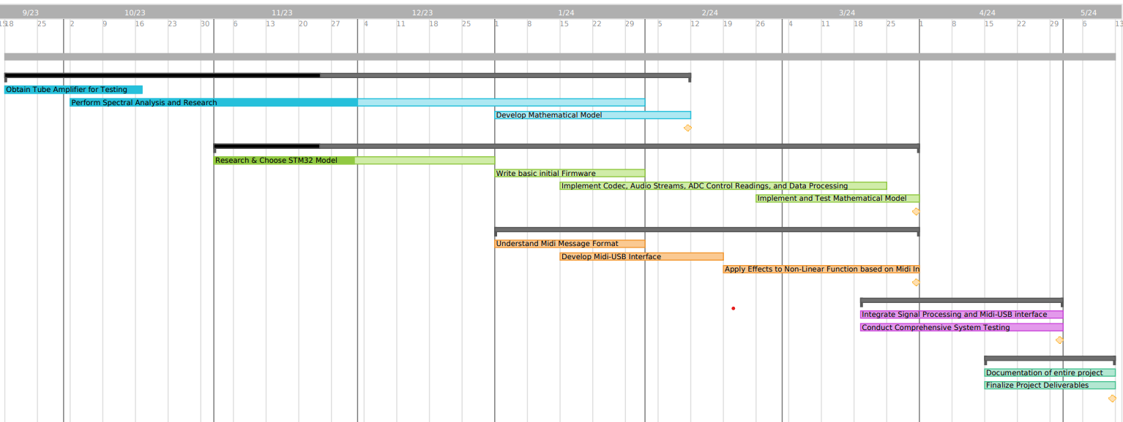

October, 2023

1. Electrical Team
   1. Hardware Testing
      1. Testing vacuum tubes for key characteristics
         1. Harmonic & Sinusoidal Distortion
         2. Filament Temperature Distortion
         3. Clipping Characteristics
2. Software Team
   1. Microcontroller Testing
      1. MIDI/Analog audio inputs
      2. Generating Distortion through digital signal processing

November, 2023

1. Electrical Team
   1. Mathematical Model for Distortion Characteristics
      1. Based on results of Hardware Testing, build a mathematical model for how tubes distort audio signals
      2. Begin work designing Analog/Digital input/output system
2. Software Team
   1. Microcontroller Design
      1. Choosing Microcontroller components best suited for audio processing based on Microcontroller Testing results
      2. Designing User Interface for Microcontroller Distortion Control

December, 2023

1. Electrical & Software Teams
   1. Design Finalization
      1. Working with team to agree upon final design specifications & parameters
      2. Prepare rough budget for needed components for final design
      3. Conferring with client to ensure satisfaction with the final specifications
   2. Design Documentation
      1. Put together a full design for the final system
      2. Editing & Checking design documentation

January, 2024

1. Electrical Team
   1. Conduct research into popular modern audio processing electronics, and the limitations therein.
2. Software Team
   1. Look at popular Digital Audio Wordstations (DAWs) and see how a distortion algorithm might be integrated into that workstation.

February, 2024

1. Electrical Team
   1. Finalize distortion algorith, and begin testing with different parameters to quantify the effects of those parameters on the final distorted output.
2. Software Team
   1. Develop initial testing bench for prototype open-source workstation given the algorithm created by the Electrical Team.
   2. Ensure that the test bench works with any arbitrary function to prepare for any finalizations on the algorithm.

March, 2024

1. Electrical Team
   1. Develop a platform for acceptance testing of finalized distortion algorithm for non-expert listeners.
2. Software Team
   1. Finalize the testbench and prepare audio samples to be used in acceptance testing

April, 2024

1. Electrical & Software Teams
   1. Conduct acceptance testing on non-expert listeners
      1. Apply the developed distortion algorithm on non-expert listeners, record their experience.
      2. Concatonate data gleaned from acceptance testing, and conduct analysis to judge the overall
      3. Conferring with client to ensure listener satisfaction with the final specifications.
      4. Take preference data from users, and change parameters as necessary to create the most pleasant listening experience possible.
   2. Design Finalization & Documentation
      1. Put together a full design for the final system, generalize parameters into final design system.
      2. Ensure satisfaction from advising professor, and complete design presentation and demonstrative design.
      3. Editing & Checking design documentation

## 2.5 Risks And Risk Management/Mitigation

* Technical Complexity:
  + *Risk:* The intricate nature of implementing a mathematical model for tube distortion and integrating it into a microcontroller may pose technical challenges.
  + *Mitigation:* Conduct thorough feasibility studies, prototype testing, and seek expert consultations to address potential technical hurdles.
* Resource Availability:
  + *Risk:* Delays or constraints in obtaining specialized testing equipment, electronic components, or access to required academic literature and code libraries.
  + *Mitigation:* Develop contingency plans, diversify suppliers, and maintain open communication to address and mitigate potential resource constraints promptly.
* Model Accuracy:
  + *Risk:* Deviations between the mathematical model of tube distortion and the actual distortion characteristics of vacuum tubes may affect the project's fidelity to the desired sound replication.
  + *Mitigation:* Regularly validate and refine the model through iterative testing and adjustments based on empirical results.
* Regulatory Compliance:
  + *Risk:* Failure to comply with relevant regulations and standards in audio engineering and electronic devices may result in legal or certification issues.
  + *Mitigation:* Stay informed about industry standards, engage legal experts if needed, and ensure that the project adheres to all applicable regulations.

Risk Management:

* Agile Development Approach:
  + Adopt an agile development methodology to enable flexibility and adaptability to evolving technical requirements. Regularly reassess and adjust project milestones based on progress and challenges.
* Diverse Skill Set:
  + Ensure that the project team possesses a diverse skill set covering areas such as electrical engineering, programming, and audio processing. Provide training opportunities to fill any skill gaps identified during the project.
* Continuous Testing and Validation:
  + Implement a rigorous testing and validation process at each stage of the project to identify and rectify issues promptly. This includes regular validation of the mathematical model, circuit design, and microcontroller implementation against empirical data.
* Communication and Documentation:
  + Establish clear communication channels within the team and maintain detailed documentation. Regular meetings, progress reports, and documentation reviews will enhance transparency and mitigate potential misunderstandings.
* Contingency Planning:
  + Develop contingency plans for potential delays, resource shortages, or technical setbacks. These plans should outline alternative approaches, backup suppliers, and strategies for overcoming unforeseen challenges.

## 2.6 Personnel Effort Requirements

Within the collaborative creative dynamic of the group, it is imperative that each member wholeheartedly commit the necessary time and intellectual effort to accomplish the tasks assigned to them. This commitment not only exemplifies a sense of responsibility but also serves as the linchpin for the group’s collective progress.

By emphasizing the significance of individual contributions, a collaborative environment can be better nurtured, fostering a shared commitment that underpins attainment of the Project Objectives. Recognizing and appreciating each member’s dedication to the overall project lays the foundation for a cooperative synergy, ensuring the group’s success in attaining its collective goals.

## 2.7 Other Resource Requirements

Beyond physical resources, additional requirements are predominantly tied to the necessity for comprehensive scientific analysis within the realm of Audio Engineering. This involves delving into extensive academic literature, particularly scholarly papers sourced from institutions such as the Audio Engineering Society (AES), and the Institute of Electrical and Electronics Engineering (IEEE).

In tandem with the necessary academic literature, this project relies on a diverse set of audio-centric code libraries, crucial for tasks like MIDI-USB integration and nuanced real-time audio signal manipulation. Access to these libraries vastly expedites the development process, ensuring a robust foundation for precise audio processing.

# 4 Design

## 4.1 Design Content

A mathematical model for:

a. Peaking Distortion

b. Harmonics of Incoming Signals

c. Filament Temperature Fluctuations

2. Digital Synthesis for:

a. Peaking Distortion

b. Harmonics Introduction

c. Filament Temperature Simulation

3. Integration for Analog inputs/outputs

a. Analog Amplification following DAC on output

b. Analog input/output ports

### 4.2 Design Complexity

The complexity inherent in procuring the requisite data for our mathematical model necessitates the orchestration of a sophisticated ensemble of equipment. Within this array, we meticulously integrate a low-power vacuum-tube amplifier, a Digital Multimeter, a Digital Oscilloscope, a Function Generator, a Focusrite Scarlett 2i2, and a laptop outfitted with recording software—specifically Audacity and MATLAB. This diverse suite of instrumentation stands as an indispensable toolkit, affording us the capacity to capture audio with optimal fidelity directly from the source, whether it be a computer employed in music tests or the function generator utilized for nuanced harmonic analysis.

This strategic amalgamation of advanced tools serves as the linchpin of our data acquisition process, enabling the meticulous recording of audio under a myriad of conditions. Each condition is thoughtfully designed to scrutinize the nuanced effects introduced by the vacuum-tube amplifier across various scenarios. Subsequently, harnessing the computational prowess of sophisticated programs such as MATLAB, we undertake the parsing of voluminous data extracted from the recorded audio files.

This computational journey becomes instrumental in conducting intricate analyses, unraveling key insights, and extracting parameters that form the bedrock of a highly precise and comprehensive mathematical model. This model, a testament to the confluence of cutting-edge instrumentation and analytical prowess, stands as a sophisticated representation of the functional distortion inherent in the audio signal's transformative journey—from its pristine, original state to the enriched, tube-amplified rendition. The meticulous orchestration of this equipment suite and computational finesse ensures a depth of analysis that aligns with the intricacies of the project's engineering complexity.

### 4.3 Modern Engineering Tools

Keysight InfiniiVision 4-Channel Oscilloscope - Signal/Frequency Analysis

Keysight EDU33210 SBE Function Generator - Reference Signal Generation

STM32F7 High-Performance Microcontroller - Real-time Audio Processing

LTSpice/PSpice - Vacuum Tube Component Simulation

Scarlett 2i2 Digital Audio Interface - Analog to Digital Converter with Adjustable Amplifier and Resolution

## 4.4 Design Context

Within the expansive tapestry of the music community, the Vacuum-Tube stands as a coveted and revered component, celebrated for its unparalleled ability to introduce distinctive distortion characteristics into an otherwise generic audio signal. This project, rooted in an acute awareness of the profound impact such analog elements can have on sonic aesthetics, directs its focus towards a specific demographic—the budget-conscious musician. This musician, while inherently drawn to the allure of the Vacuum-Tube's acoustic qualities, navigates the delicate balance of a finite financial spectrum, seeking to harness these sought-after tonal nuances without succumbing to the exorbitant costs associated with acquiring high-quality analog equipment.

By homing in on the musician on a budget, this project extends an inclusive invitation to a community of artists who, despite financial constraints, yearn to imbue their soundscapes with the warmth, richness, and distinctive coloring that the Vacuum-Tube uniquely imparts, without having to sacrifice quality for reduced cost. This endeavor transcends the mere replication of sound; it encapsulates a mission to democratize access to the sonic aesthetics of the Vacuum-Tube, fostering a creative environment where financial limitations cease to be a hindrance to the pursuit of musical excellence. In essence, this project becomes a sonic egalitarian venture, ensuring that the transformative power of the Vacuum-Tube is not confined to the realms of luxury but becomes an accessible and integral component in the artistic journey of every budget-conscious musician.

While serving as a cost-effective gateway to the coveted vacuum-tube sound, the OmniTube amplifier distinguishes itself by integrating MIDI-Instrumental functionality, along with a universally robust open-source foundation which makes it compatible with any processing system the artist might have available to them. This addition not only retains its essence as a traditional Tube-Preamp but expands its utility, offering artists unparalleled creative freedom. This versatility transforms the OmniTube into a dynamic platform that accommodates a spectrum of creative visions. The MIDI-Instrumental functionality along with the freedom of open-source construction allows seamless integration with various MIDI-enabled instruments and software, enabling real-time manipulation of parameters, textures, and nuances. In essence, the OmniTube transcends its budget-friendly identity, becoming a catalyst for innovation and inspiration across diverse musical genres.

| **Area** | **Description** | **Examples** |
| --- | --- | --- |
| Public health, safety, and welfare | Promotes self-manufacture of the product due to availability and cost effective materials. All dangers therein are thus possible. | An individual burns themselves while attempting to solder the PCB for the Microcontroller necessary for the device to work properly. |
| Global, cultural, and social | This project widens the creative freedom for artists wishing to expand upon the familiar Tube-Amp sound. | An artist otherwise limited by the analog simplicity of a Vacuum-Tube amplifier is able to improve upon the sound by changing the tonal characteristics as they see fit. |
| Environmental | Materials necessary for individuals to manufacture their own versions of the Project device may cause environmental problems. | Use/Misuse of 3D-printed materials may cause a greater quantity of plastic-waste to enter landfills. |
| Economic | Reduced cost-of-entry into an otherwise exclusive field of Vacuum-Tube sound for musicians. | Musicians who wish to enter the performance/recording scene where the cost barrier would be otherwise insurmountable can now afford to create the music they wish to. |

### 4.5 Prior Work/Solutions

In our exploration of products available online, we've come across numerous claims of digitally emulating the distinct sound of a vacuum tube amplifier. Notably, these offerings predominantly manifest as VSTs (Virtual Studio Technology), existing solely in the digital realm and requiring a computer for operation. Our product diverges from this digital landscape as we envision it to be a tangible, physical amplifier, providing a unique and authentic experience beyond the confines of virtual emulation. This differentiation is not only in the nature of our product but also in the user interaction it offers, distinct from the computer-centric operation of VSTs. Here are key points that underscore the differences:

* Physical Presence:
  + *Online Products:* Existing as VSTs, they lack a tangible, physical form and are confined to digital platforms.
  + *Our Product:* A physical amplifier that can be interacted with directly, offering a hands-on experience.
* Operational Independence:
  + *Online Products:* Dependence on a computer for operation, limiting flexibility and mobility.
  + *Our Product:* Operates independently, allowing users to engage with it without being tethered to a computer.
* Authentic Amplification:
  + *Online Products:* Emulate tube amplifier sounds in a digital environment.
  + *Our Product:* Physically replicates the authentic sound characteristics of a vacuum tube amplifier.
* User Interaction:
  + *Online Products:* Interface through computer screens, limiting tactile engagement.
  + *Our Product:* Facilitates direct user interaction, offering a more immersive and intuitive experience.
* Versatility:
  + *Online Products:* Primarily suited for digital audio workstations and studio setups.
  + *Our Product:* Versatile application, suitable for live performances, rehearsals, and various musical environments.

By materializing our vision as a physical amplifier, we aim to bridge the gap between digital emulation and tangible, authentic amplification, offering musicians a unique and versatile tool for their sonic endeavors.

## Design Decisions

To ensure the greates level of consumer usability as possible, our design is built around both easy MIDI integration, and compatibility with the affordable and commercially common STM-32F7 microcontroller, which is the best general analog for a microcontroller likely for a home-built Vacuum-Tube Emulation system. Usually, an ADC with a resolution of between 12 and 16 bits is used in commercially available Digital Audio Systems. But, with greater resolution comes the necessity for greater processing power for the Microcontroller. So, to strike a balance between audio quality and processing power, we have elected to utilize the 12-bit ADC/DAC option for the STM32F7’s Audio input/output system to ensure that the distortion effects introduced by our algorithm will withstand even lower bit resolutions without severe quality degredations.

In our design approach, we prioritize versatility by incorporating robust connectivity options into the OmniTube amplifier. This decision encompasses standardized Analog inputs for traditional audio sources, ensuring compatibility with instruments like guitars and keyboards. Simultaneously, we embrace MIDI standardized messages for the Instrumental Array, providing users with a pathway for exploring innovative MIDI-controlled manipulations.

Along with resolution, and I/O format considerations, we also have to consider the Audio Processing itself, which we have decided to conduct on the STM32F7 Microcontroller. This Microcontroller is very easily commercially available, allowing for even inexperienced artists to easily gain access. Also, it is powerful enough to conduct all the audio processing we need plus some due to it utilizing the entire computational abilities of the Cortex-M7 core processor.

## Proposed Design

Modulating A Tube’s Nonlinear Function

The Function

The baseline function used to replicate the diction effects introduced by a 12ax7 Vacuum tube, the most common electron tube used in audio amplification/preamplification circuits, was found by Yamaha engineers to be as follows:

$y =(\frac{3x}{2})(1-\frac{x^{2}}{3})$

Where ‘y’ is the amplitude of the output given the input amplitude value ‘x’. This nonlinear distortion function has the following graph:

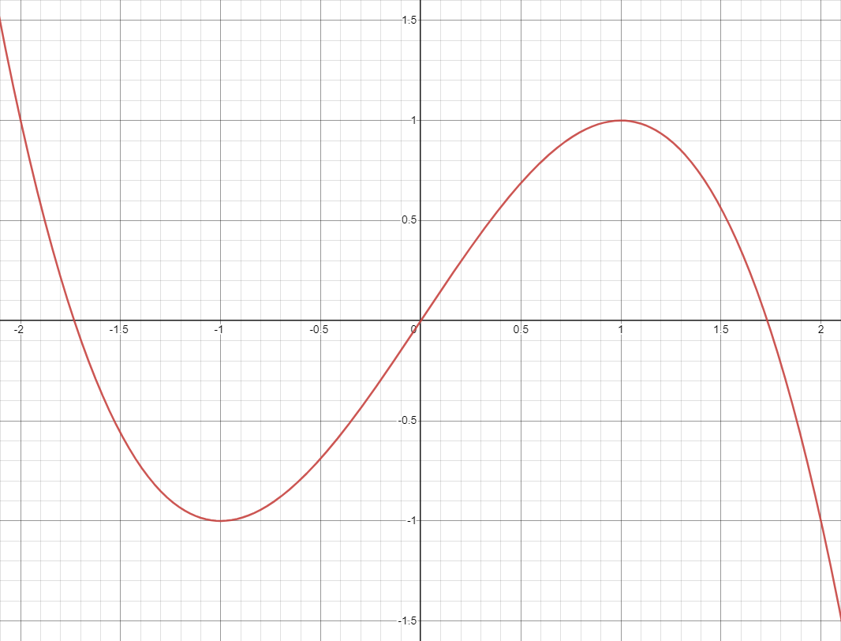

In previous testing, it has been observed that the pronounced curves of this function can cause somewhat severe discordant harmonic dissonance when the amplitude of the input audio leaves the nonlinear region of the function. To combat this, and improve the overall quality and perceived ‘smoothness’ of the harmonic content, the following minor change has been made to the function:

$y =(\frac{3sin(x)}{2})(1-\frac{{sin(x)}^{2}}{3})$

When this graph is plotted, the following curve appears (shown alongside the original function (in red) is the edited function (in blue)):

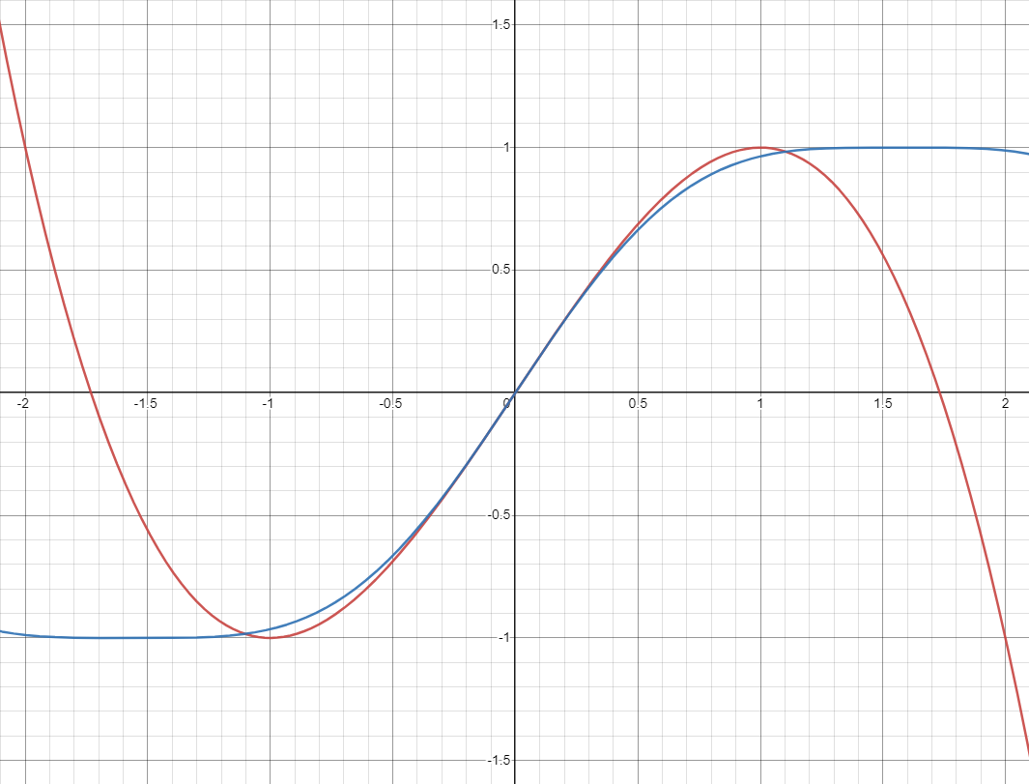

This edited version of Yamaha’s original Vacuum-Tube emulation function diverges slightly from the original function as the amplitude of the input signal reaches the limits of the curve. But, that taper away from the linear region is less abrupt, allowing for an overall smoother sound at the output. Though, this smoother taper from the linear region comes at the cost of a reduced length for the linear region itself.

Given this equation and graph of ‘y’, we can make certain assertions about the behavior of an input signal when it is modulated with the above function.

1. When input amplitude (x) is small, between approximately -0.20 and 0.20, the amplification of the input function will react relatively linearly (with a slope of $\frac{3}{2}$). In this region, the distortion effects introduced by the nonlinear curve are minimal, and are not readily audible in the output audio signal.
2. Beyond this ‘linear region’, the amplification of the input function will follow the nonlinear curve towards the peak values of y (-1 and 1). In this region, distortion effects become more evident as the input amplitude increases.

These assertions made through visual inspection of the modulation function ‘y’ can also be compiled with some observations made in testing using single-frequency sinusoidal inputs.

1. At low levels of input gain, added harmonic content is minimal regardless of frequency.

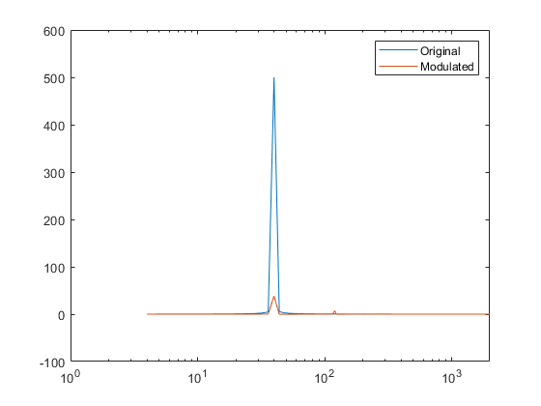

*FFT Spectral Graph for 40 Hz sine wave passed through nonlinear function w/ input gain of 1 V/V*

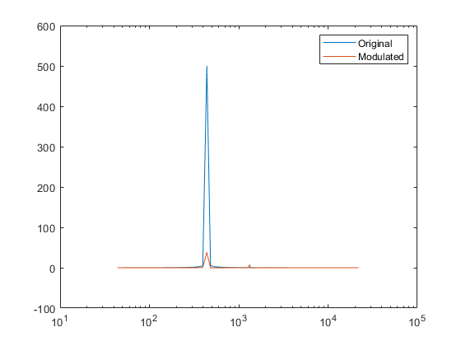

*FFT Spectral Graph for 440 Hz sine wave passed through nonlinear function w/ input gain of 1 V/V*

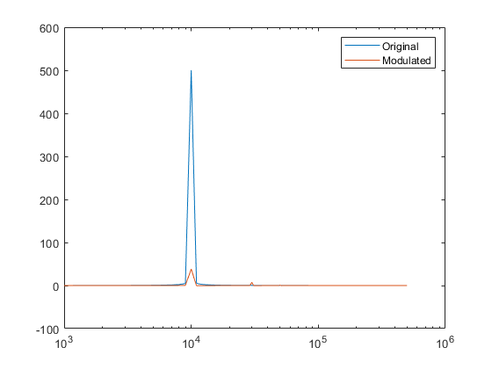

*FFT Spectral Graph for 10 kHz sine wave passed through nonlinear function w/ input gain of 1 V/V*

1. At high levels of input gain, the distortion on the output signal is severe enough to add several noticeably audible harmonics regardless of frequency.
   1. For higher frequencies, these harmonics will be well outside of the human range of hearing, resulting in the perceived reduction of loudness for higher frequencies and increase in perceived loudness for lower frequency harmonics.

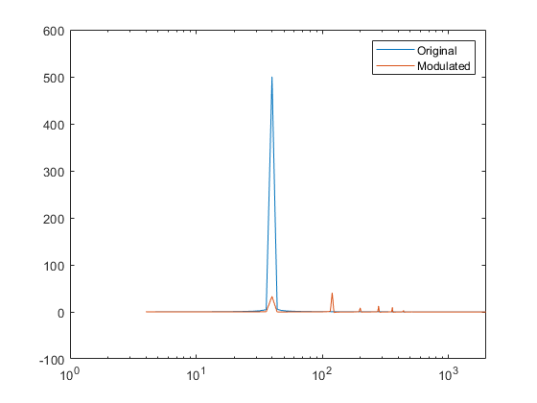

*FFT Spectral Graph for 40 Hz sine wave passed through nonlinear function w/ input gain of 3 V/V*

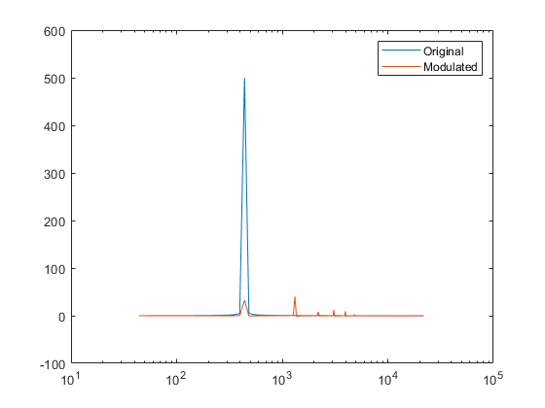

*FFT Spectral Graph for 440 Hz sine wave passed through nonlinear function w/ input gain of 3 V/V*

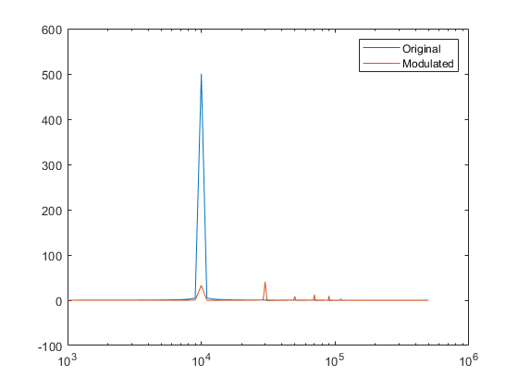

*FFT Spectral Graph for 10 kHz sine wave passed through nonlinear function w/ input gain of 3 V/V*

From these assertions and the Fast Fourier Transform graphs accompanying them, we can reliably relate input gain to added harmonic content. In the MATLAB implementation of this function, this variable is known as ‘InputAmp’.

But beyond simply changing the gain of the input function, what changes can be made to the nonlinear function itself? And what effects does this have on the output audio?

**Changing Function Parameters**

Learning which attributes of the nonlinear function lead to which specific outputs is of vital importance, but is not trivial. To do this, first we must specify which parameters in the function can be changed, and how to change them.

Also, though there are a great many parameters that can be changed, we must find the parameters that, when changed, result in the greatest and most audibly appealing outputs. Because of the inherently subjective nature of audio modulation, the parameters listed below have been chosen due to their unique effect on tested output audio signals.

* Function Amplitude
  + This is the most basic parameter to edit. The best method to achieve this is to simply multiply the overall function by a constant. This will change the peaks of the function by a factor of this constant. This, we will call Function Gain, or ‘Fg’ for short.
$y =Fg * (\frac{3sin(x)}{2})(1-\frac{{sin(x)}^{2}}{3})$

* This amplitude change can also be integrated into the function as an addition to the numerator of the first term to allow for more fine amplitude control, that appears as follows:
$y =(\frac{(3 + Fg) sin(x)}{2})(1-\frac{{sin(x)}^{2}}{3})$

* Changing the amplitude of the function will reduce the slope of the linear region, thus reducing the overall gain of the output signal. In the MATLAB code for this function, the former implementation of the amplitude parameter is called ‘outAmp’. Meanwhile, the latter implementation of this parameter is called ‘vSquish’ in the MATLAB code.

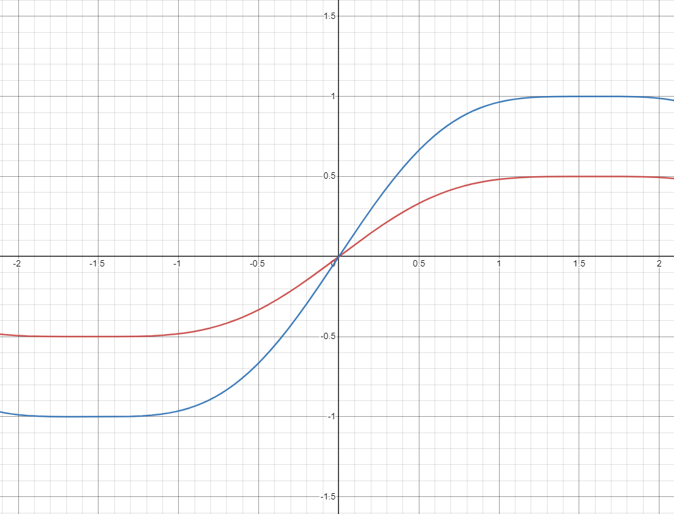

*Graph of Nonlinear function with ½ multiplier (red) compared with original function (blue)*

* Function Phase
  + Changing the phase of the function will change the horizontal location of the function, in turn shifting the linear region horizontally, without changing the slope. We can call this variable Phase Shift, or Ps for short.
$y =(\frac{3sin(x - Ps)}{2})(1-\frac{{sin(x - Ps)}^{2}}{3})$

* Moving the nonlinear region of the function horizontally will cause the output signal to begin peaking at significantly lower amplitude on the negative side, and significantly increase the peaking-amplitude on the positive side, overall adding more distortion effects to the output signal.
* In the MATLAB implementation of this function, the phase shift variable was named ‘Pshift’.

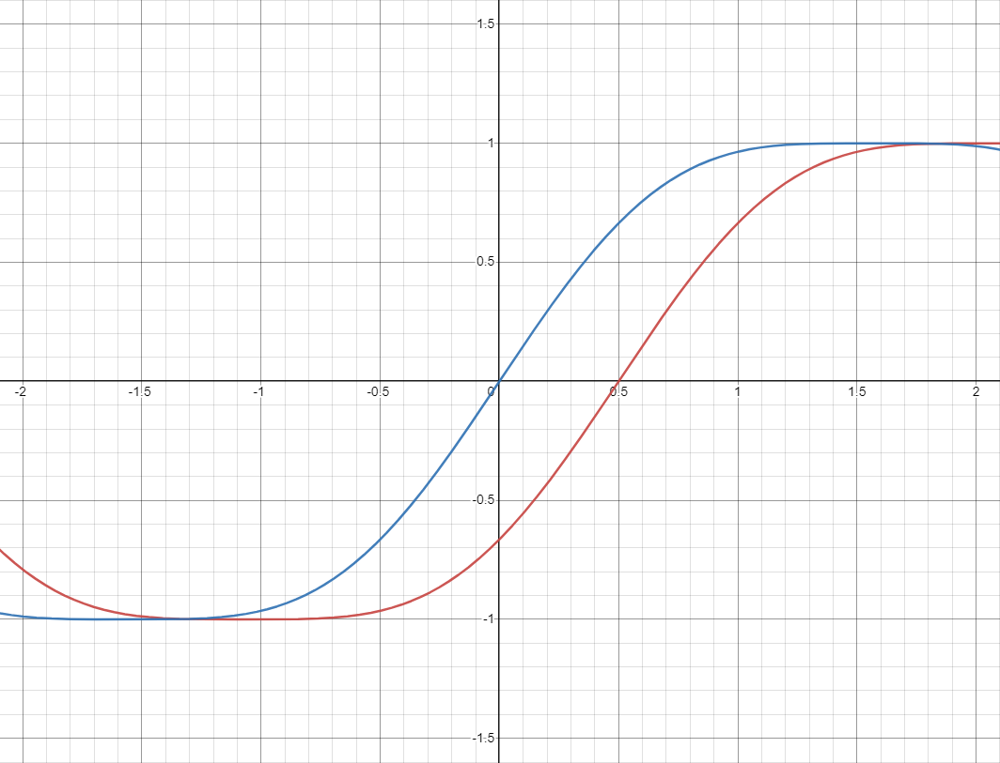

*Graph of Nonlinear function with Phase shift of ½ (red) compared with original function (blue)*

* Function Compression
* Nonlinear functions of this sort can also be compressed in both the vertical and horizontal directions. The vertical compression has already been covered as the variable ‘vSquish’ in the MATLAB Code (the Fg variable shown above).
* This Horizontal Compression, Hc for short, is implemented into the function by multiplying the x within the term by the Hc parameter as follows:
$y =(\frac{3sin(Hc * x)}{2})(1-\frac{{sin(Hc * x)}^{2}}{3})$

* And when implemented alongside the Vertical Compression (Output Gain Adjustment, Fg), the function looks as follows:

$y =(\frac{(3 + Fg)sin(Hc * x)}{2})(1-\frac{{sin(Hc * x)}^{2}}{3})$

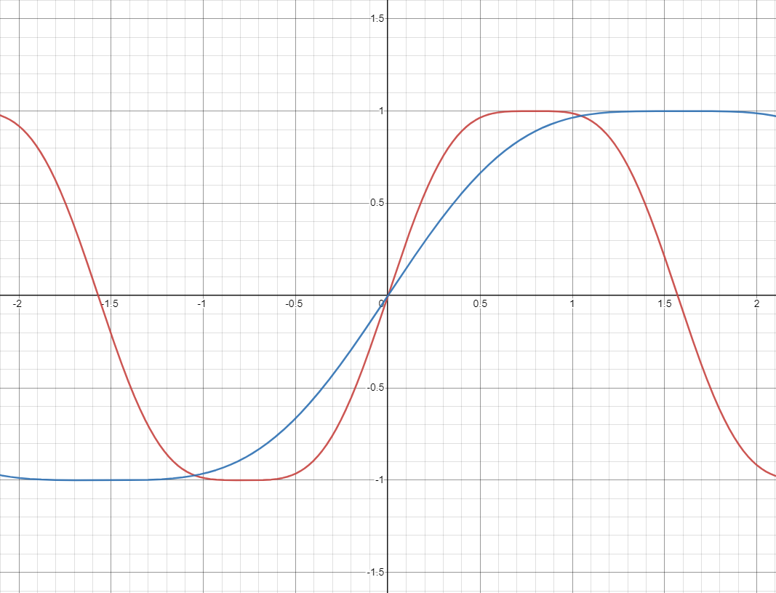

*Graph of Nonlinear function with Horizontal Compression of 2 (red) compared with original function (blue)*

* Input DC Offset
* Though not technically a parameter modification, introducing a DC offset to the input is a relatively reliable way to boost the sub-harmonic frequencies. Though it is not able to add in low harmonics, it can substantially boost them.
* It should be noted that while adding a DC offset to the input can add low harmonics, it must be used in conjunction with vertical shifting the function itself to minimize the unwanted dissonance that can very easily become overwhelming.
* In the MATLAB code written for this demonstration, the DC offset is introduced with the ‘constAdd’ variable.

**Oscillating Function Parameters**

An exciting option that has been explored to distinguish the audio output from one of a traditional Vacuum-Tube based audio amplifier is the idea of oscillating the various parameters detailed in the previous section at sub-harmonic frequencies. Or those frequencies that exist beneath the lowest harmonic of the input signal.

To oscillate any specific parameter is as simple as changing that parameter from a constant variable, as shown above, into a sinusoidal function. An example of this is shown below in how to implement an oscillation to the Horizontal Compression could be implemented mathematically:

$y =(\frac{(3 + Fg)sin(Hc*(sin(HcFreq * t)) * x)}{2})(1-\frac{{sin(Hc*(sin(HcFreq * t)) * x)}^{2}}{3})$

In the above function, the sinusoid $Hc * sin(2 π * HcFreq * t)$ is representative of a sinusoidal input with frequency HcFreq (in Hz).

This same procedure can be taken with any of the parameters noted in the previous section of this document.

Below is shown the effects that an oscillation of the Horizontal Compression at a frequency of 2 Hz can have on the waveform for a 440 Hz sine wave, when it is compared to the 440 Hz sine wave without that modulation.

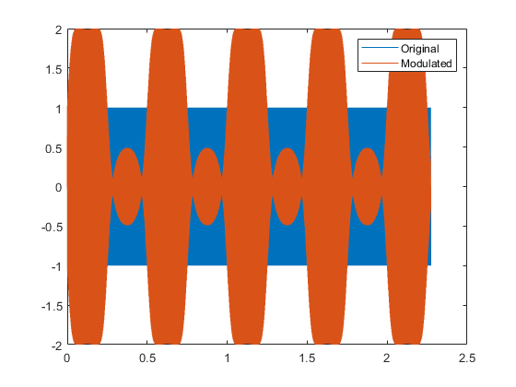

*440 Hz sine wave w/ Hc oscillated at 2 Hz (Orange) compared to the unmodulated signal (blue)*

It is important to note that in the above figure, the waveform is shown over a period of approximately 2.27 seconds to demonstrate the interesting interference pattern introduced by the oscillation of the Horizontal Compression.

Below is shown yet another case of parameter oscillation. Though, in this case, both the Horizontal Compression as well as the Vertical Compression have been oscillated at 2 Hz, with a 90 degree offset in phase in the oscillations.

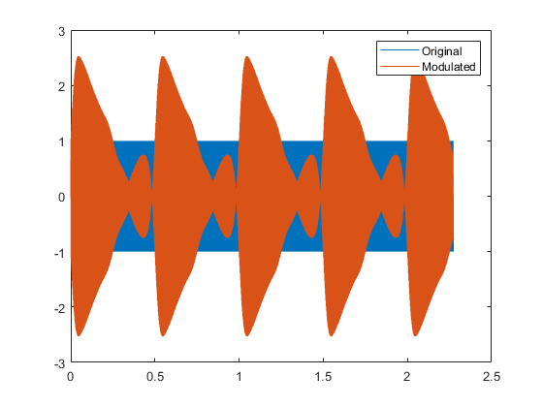

*440 Hz sine wave w/ Hc & Vc oscillated at 2 Hz with 90 degree phase offset (Orange) compared to the unmodulated signal (blue)*

The oscillations shown above are just two of the options for how an input signal passing through the nonlinear function might be modulated beyond what is normally possible. But, there is a wide variety that simply have not been tried yet.

**Conclusions & Final Decisions**

In this report, we have compiled three separate parameters that, in our observations, have caused the most significant and interesting change to the output signal. The nonlinear function is listed below, with all parameters included, followed by the explanation of each parameter.

$y =(\frac{(3 + Fg)sin((Hc * x) - Ps)}{2})(1-\frac{{sin((Hc * x) - Ps)}^{2}}{3})$

1. Function Amplitude (Fg)

Allows us to control output peaking levels by changing the cutoff threshold of the nonlinear function. Directly changing this parameter will change the slope of the linear region, thus changing the amplification characteristics. Though, this can be combated by also changing the Horizontal Compression of the function to change the peaking parameters while also maintaining the slope of the linear region.

1. Function Phase (Ps)

Allows us to introduce peaking distortion effects without having to change the input level or the function amplitude. Oscillating this function certain bounds can create some very interesting effects, though mostly serves to quiet and louden the audio periodically.

1. Function Compression (Hc)

Grants us control over the slope of the linear region of the function, allowing us to, at will, change the harmonic characteristics of the output signal. Specifically, a more severe Horizontal Compression can amplify upper harmonics significantly, though this is at the detriment of overall signal attenuation.

The Nonlinear Distortion Function has been derived using the mathematical model developed by Yamaha engineers during their attempts at Vacuum Tube emulation. Using this Nonlinear function as a jumping-off point, we are refining our mathematical model for what makes a Vacuum-Tube sound like a Vacuum-Tube through experimental development. The distortion function was then tested using the following MATLAB Simulink Diagram for the process of making decisions on which specific parameters should be emulated:

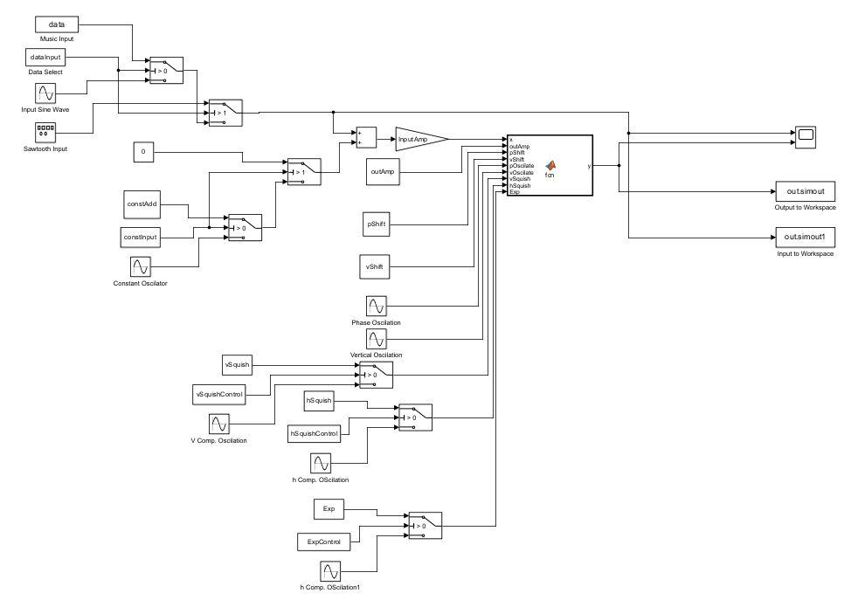

The above system was then controlled and its outputs processed by utalizing the following matlab script:

clear

clc

[Music,fs] = audioread("C:\Users\Harry\OneDrive\Desktop\Documents\MATLAB\Snr. Design\Modulation Testing (2-26-24)\Audio Files (1)\New Base Audio\Clip2.wav");

data(:,2) = Music;

fs = 44100;

for i = 1:length(data)

data(i,1) = (1/fs) * i;

end

[DataTHD, DataHarmPower, DataHarmFreq] = thd(data(:,2), fs, 10);

%Data Control

dataInput = 1; %0 = Sinusoide, 1 = Music, 2 = Sawtooth

%Constant Control

constInput = 2; %0 = Oscilator, 1 = Constant, 2 = Constant Zero

%Exponent Control

ExpControl = 1; %0 = Oscilator, 1 = Constant

%Compression Controls

vSquishControl = 1; %0 = Oscillator, 1 = Constant

hSquishControl = 1; %0 = Oscillator, 1 = Constant

%Bandpass Frequency Control

BPControl = 1;%0 = no effect, 1=Bandpass Filter

%Attributes of the Sinusoidal/Sawtooth Input

inAmp = 1;

inFreq = 440;

if(dataInput == 0 || dataInput == 2) %Sinusoide/Sawtooth

SimTime = (1/inFreq) * 1000;

fs = inFreq * 100;

end

if(dataInput == 1) %Music

fs = 44100;

SimTime = (1/fs) * length(data);

end

%Input & Output Gain

InputAmp = 0.25; %1 = no effect

outAmp = 1; %1 = no effect

%BandPass Filter Adjustments

BPGain = 10;%1 = no effect

BPLowCut = 1;

BPHighCut = 100;%0 = Choose Harmonic, 0> = Frequency (Hz)

Harmonicn = 1;%if BPHighCut = 0, DataHarmPow(Harmonicn) (>= 1)

%Horizontal & Vertical Shift

pShift = 0; %0 = no effect

vShift = 0; %0 = no effect

%Constant add &/or Oscilate

constAdd = 0; %0 = no effect

constFreq = 0; %0 = no effect

%Exponent Effect

Exp = 2; %2 = no effect

expOscFreq = 0; %0 = no effect

%Horizontal & Vertical Compression Amplitudes

vSquish = 0; %0 = no effect

hSquish = 5; %1 = no effect

%Horizontal and Vertical Compression Oscilators

vSquishFreq = 0; %0 = no effect

hSquishFreq = 0; %0 = no effect

%Horizontal and Vertical Compression Phase

vSquishPhase = 0; %0 = no phase

hSquishPhase = 0; %0 = no phase

%Horizontal & Vertical Oscilation Frequency

pOscFreq = 0; %0 = no effect

vOscFreq = 0; %0 = no effect

%Horizontal & Vertical Oscilation Amplitude

pOscAmp = 0; %0 = no effect

vOscAmp = 0; %0 = no effect

out = sim("C:\Users\Harry\OneDrive\Desktop\Documents\MATLAB\Snr. Design\Modulation Testing (2-11-24)\Simulink (1)\Func_tester.slx");

if(BPControl == 1)

if(BPHighCut == 0)

outLimit = highpass(lowpass(out.simout1, DataHarmFreq(Harmonicn) , 44100), BPLowCut, 44100);

else

outLimit = highpass(lowpass(out.simout1, BPHighCut , 44100), BPLowCut, 44100);

end

outSignal = out.simout + (BPGain * outLimit);

else

outSignal = out.simout;

end

%Waveform Graphs

fig = figure(1);

subplot(2,1,1);

nexttile

plot(out.tout, out.simout1);

title('Original Audio');

hold on

nexttile

plot(out.tout, outSignal);

title('Modulated Audio');

hold off

%FFT Calcs

funcOut_fft = fft(outSignal);

funcIn_fft = fft(out.simout1);

f = (0:length(out.simout)/2-1) * (fs/length(out.simout));

%.mp3 File Writing

% audiowrite("C:\Users\Harry\OneDrive\Desktop\Documents\MATLAB\Snr. Design\Modulation Testing (2-11-24)\Audio Files (1)\Sample Test Audio\Original Audios\Original Audio (JazzSample1).mp3", out.simout1, 44100);

audiowrite("C:\Users\Harry\OneDrive\Desktop\Documents\MATLAB\Snr. Design\Modulation Testing (2-26-24)\Audio Files (1)\Trials Audio\Harmonic Audio\Audio2.wav", outSignal, 44100);

%FFT Graphs

fig2 = figure(2);

subplot(2,1,1);

nexttile

semilogx(f, funcIn_fft(1:length(f),1));

title('Original Audio');

hold on

nexttile

semilogx(f, (funcOut_fft(1:length(f),1)));

title('Modulated Audio');

hold off

%THD Calcs

[THDin, inHarmPower, inHarmFreq] = thd(out.simout1, fs, 8);

[THDout, outHarmPower, outHarmFreq] = thd(outSignal, fs, 8);

HarmPowDif = outHarmPower - inHarmPower;

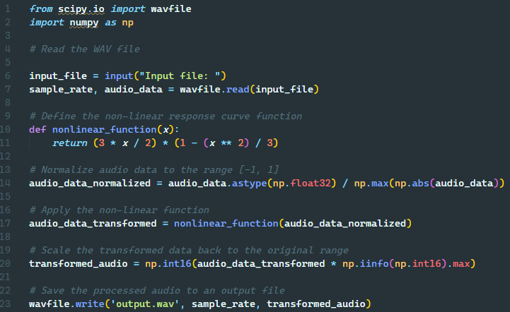

Using the following Code implementation of the above nonlinear function, we have been able to create an exceptionally rudimentary version of the overall distortion we wish for the final product.

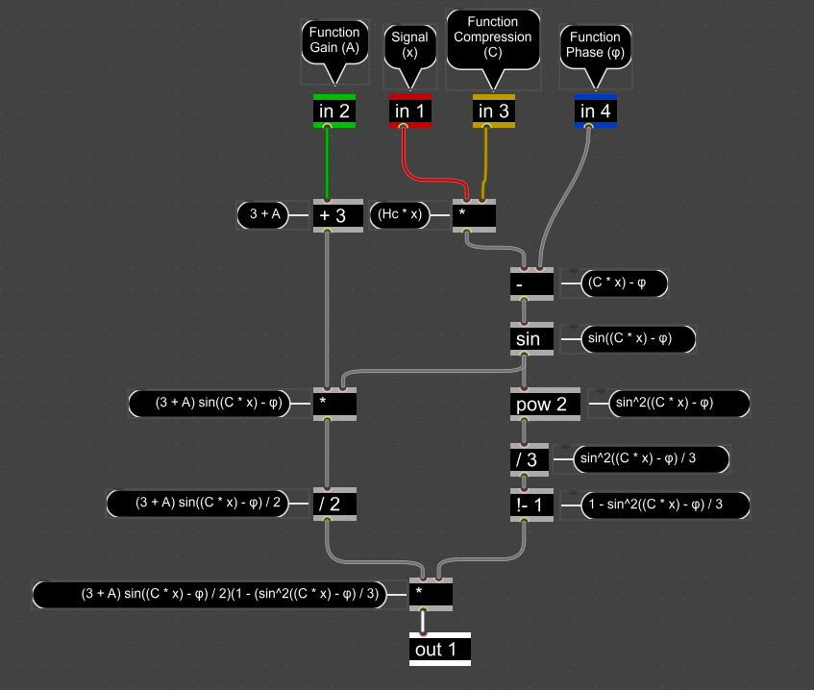

Using the signal flow as shown in the above figure, four analog inputs can be used to effect the various parameters that will effect the signal as it moves along the chain.

### 4.7.1 Design 0 (Initial Design)

### Design Visual and Description

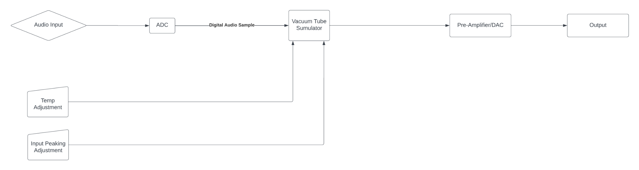

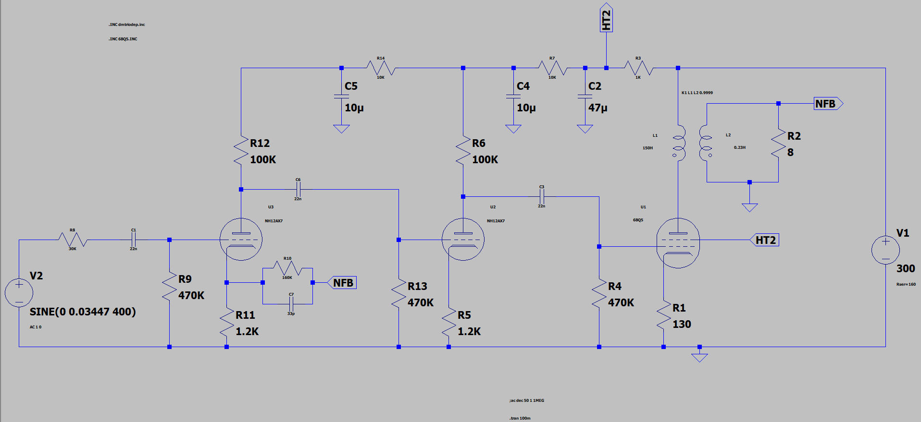

Our initial design relied on running a PSpice model of a Vacuum-Tube Audio Amplifier following design for a 5 Watt Vacuum-Tube based Pre-Amplification system utilizing 12AX7 Triodes for the both filtering stages and a 6BQ5 Power-Pentode for the final Amplification Stage.

In terms of User Inputs, we decided to include user control over the temperature of the Filament temperatures within the simulated circuit shown above, along with an Input Peaking control that would change the input amplitude to either enter or avoid the saturation region of the Simulated Triodes. (This input area would take the place of the Sinusoidal Voltage Generator to the far left of the above diagram).

Once the Audio Sample passes through the Simulated Circuit, it would then pass into the Digital to Analog Converter, then to the output.

### Functionality

This design was created to as closely as possible emulate the specific qualities of the Vacuum-Tube Preamplifier it was based off of, which is the Fender ‘57 Custom Champ 5 Watt Vacuum-Tube Amplifier.

This being the designed functionality, the user would be able to introduce the Vacuum-Distortion the same way that they might utilize any other Effects-Based Direct Input (DI) unit, wherein the user would plug in the audio source into the ¼” TRS (Tip-Ring-Sleve) port on the front of the device, and run a cable between the ¼” TRS Output of the device and the secondary amplification/recording device they plan to use.

During use, the user would be able to use the knobs on the exterior of the device to effect systems such as the simulated Tube Filament Temperature or the Input Peaking to introduce distortion to their liking.

### 4.7.2 Design 1 (Design Iteration)

Between Design Iteration 0 and Design Iteration 1, the central concept for how the effect of Vacuum-Tube emulation would be achieved. Following some extensive research, it was discerned that simulating the circuit as we originally intended would be wildly computationally expensive, as an individual simulation would need to be run for each individual audio sample in real time. This would be totally unachievable given the naturally limited computational resources of a Microcontroller platform.

Along with computational problems, there also arose the issue of accuracy, as during out limited testing with the format of using a Circuit Simulation to introduce the desired distortion effects, it was seen that even a minute change in any of the parameters caused the output to vary wildly and the audio quality to degrade extensively.

To resolve this computational intensity problem along with the acoustic dissonance problem we decided to adopt a more robust and altogether computationally prudent method of mathematical modeling for our next design iteration.

Also in this iteration comes the idea of the MIDI Instrument. In simulating the distortion using a mathematical model instead of a Circuit Simulation, it is very simple to run a MIDI Message into the system and have it run an oscillation of the final audio signal given overwhelming creative freedom to the artist using the device.

### Design Visual and Description

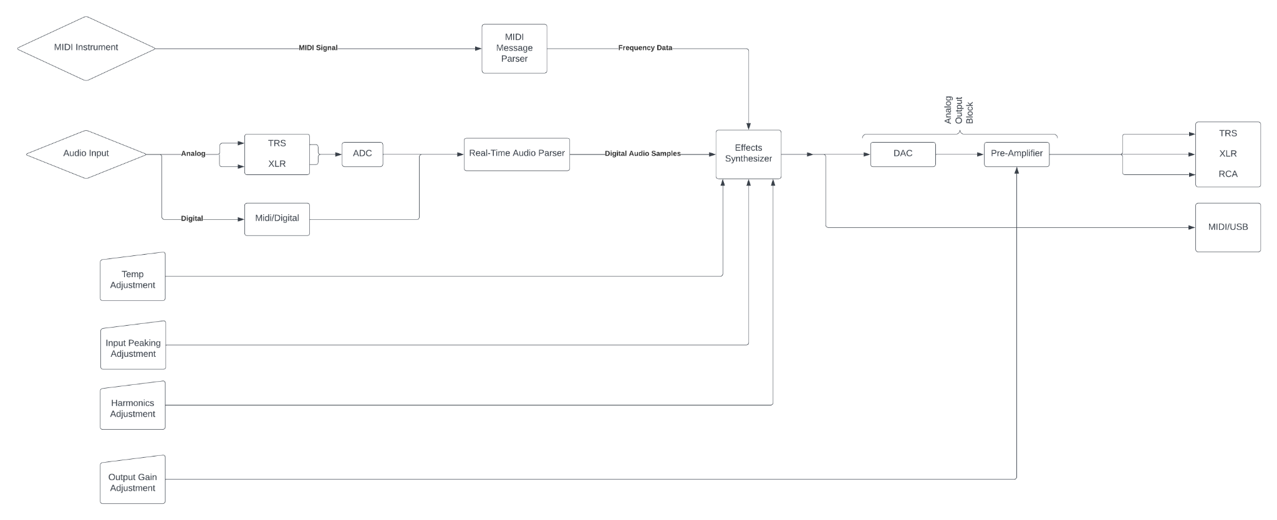

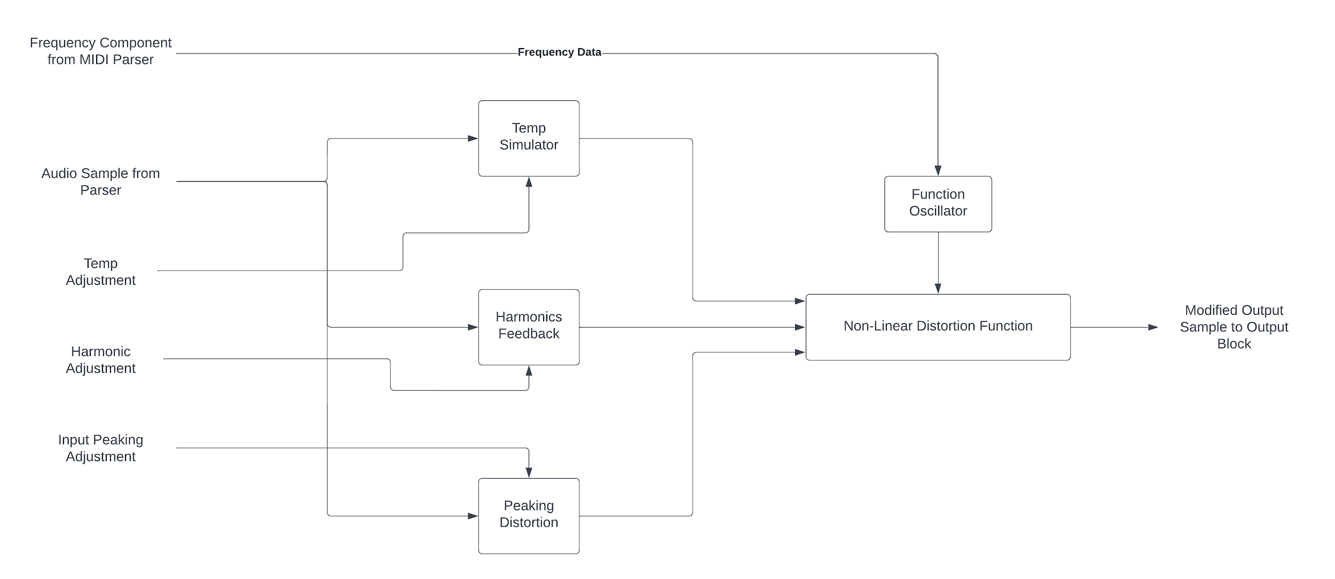

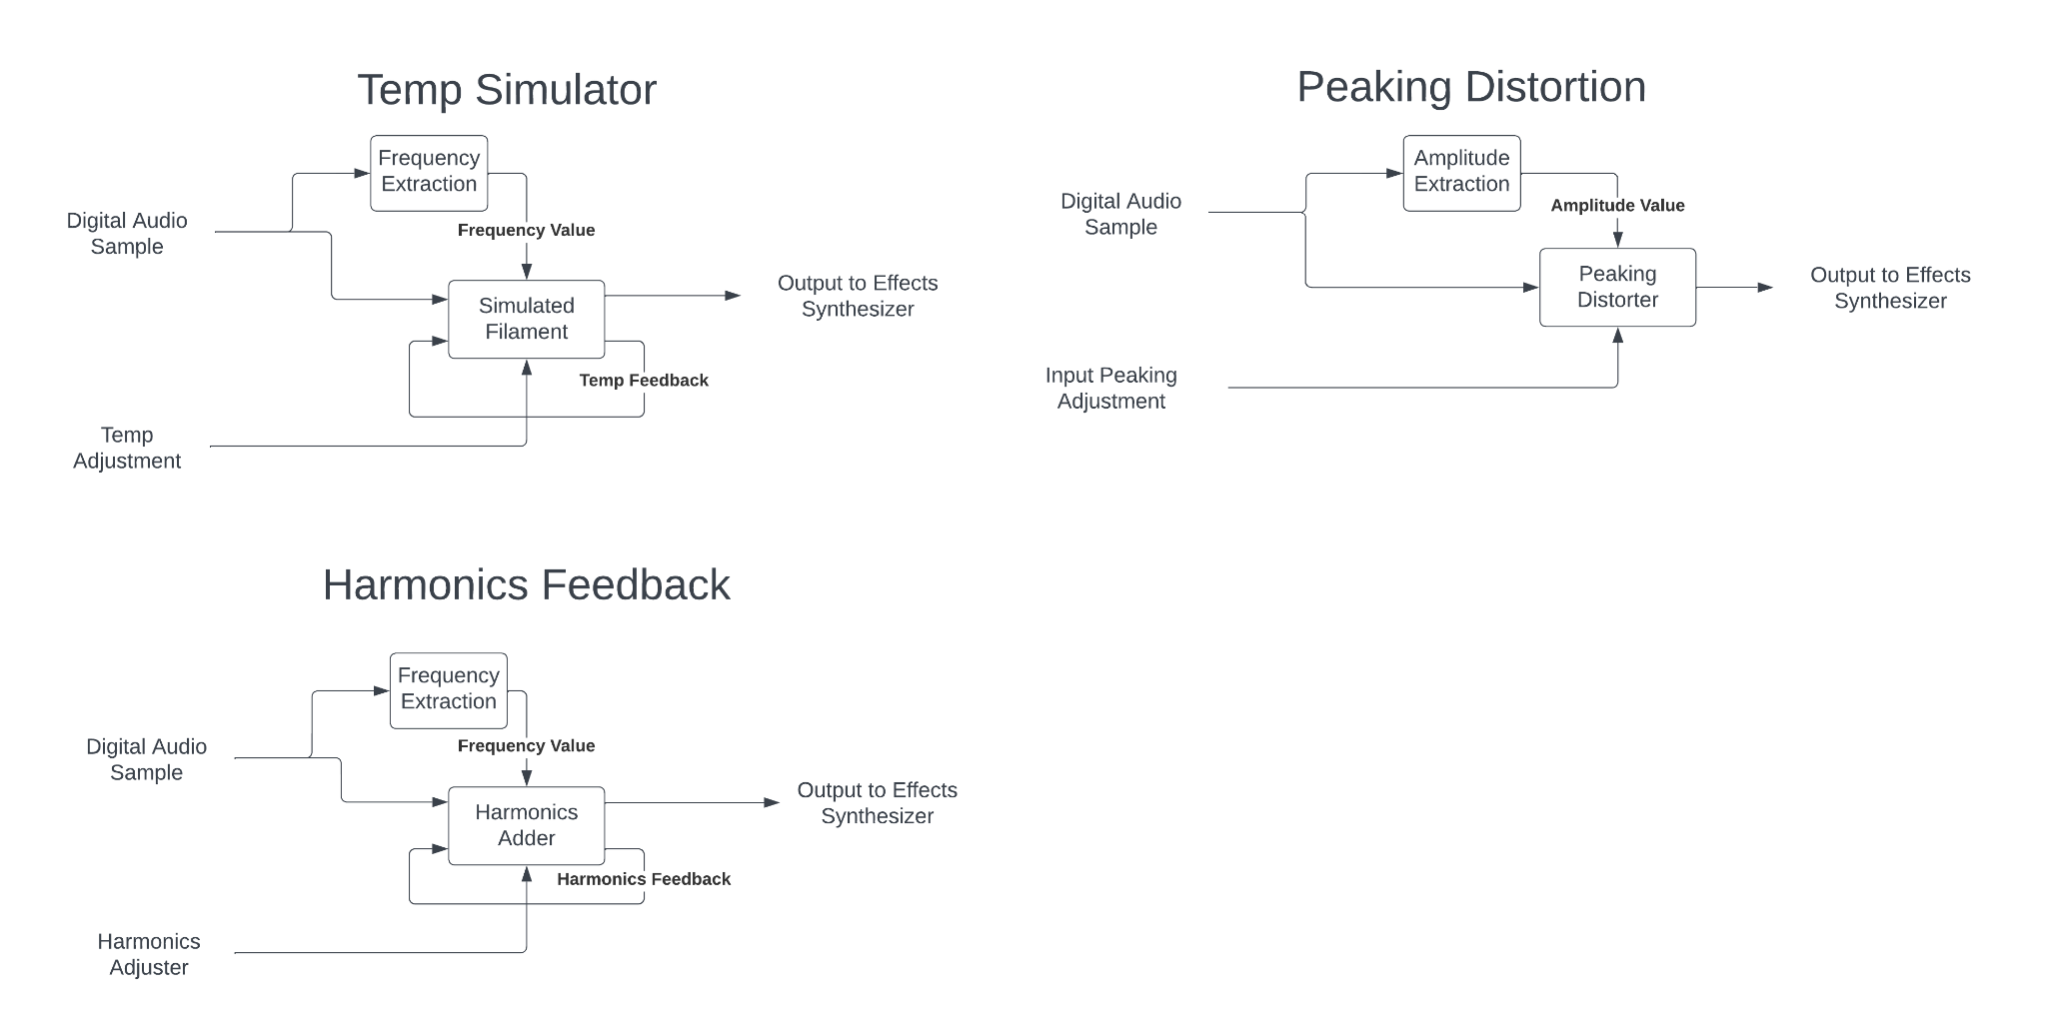.

In the above three flowcharts, the method for approximating the distortion of a Vacuum-Tube amplifier using a programmed mathematical model is shown. When the audio signal enters the system, it is first processed from its original format into a unified AES3 digital audio signal, whose samples can then be parsed out before being sent to the Effects Synthesizer for processing.

Along with the two inputs from the previous iteration of the design, the Temp Adjustment and the Input Peaking Adjustment, two more user adjustable settings are available. The Harmonics Adjustment, which adjusts the severity of the harmonics added in by the non-linear function, along with the Output Gain Adjustment, which simply adjusts the gain of the final analog amplifier at the end of the circuit.

Once within the Effects Synthesizer, the audio sample is run in parallel through the three separate effects, where the distortion is added to each before the signal is recombined in the final audio processor. It is also within the effects synthesizer that the MIDI signal is added to modulate the Nonlinear Function at the heart of the mathematical model.

This design iteration has made many major improvements over the initial design beyond simply being computationally cheaper. It also massively increases the sensitivity with which the distortion effect can be manipulated by the user and thus extends creative freedom without adding unneeded control complexity.

## 4.8 Technology Considerations

**STM32 Microcontroller Platform:**

Achieving real-time processing is critical for musical applications. Balancing the complexity of signal processing algorithms with the need for low-latency performance is a key trade-off. The processing capabilities of microcontrollers, including the STM32 baseline we have selected, are limited compared to more powerful processors. This may impose constraints on the complexity of signal processing algorithms that can be implemented. While a STM32 is powerful, optimizing code for memory and processing efficiency is crucial to make the most of the limited resources.

**MIDI-USB Interface:**

MIDI-USB technology offers a standardized and widely accepted communication protocol for musical instruments. It provides a convenient way to connect and communicate with various MIDI-enabled devices.

USB interfaces might introduce latency, and careful consideration is required to minimize this latency for real-time audio processing..

**Tube Amplifier for Testing:**

Tube amplifiers can provide a unique and desirable audio character that many musicians appreciate. The inclusion of a tube amplifier in testing allows for a more realistic mathematical model and evaluation of the system's performance.

## 4.10 Design Analysis

Developing the mathematical distortion algorithm that was able to emulate the model developed by the engineers at Yamaha was a great success, but integrating that design into the STM-32F7 microcontroller specifically was slightly less successful. Though our assertion that the STM-32 platform is a good analog for commercially available audio processing systems was well founded, the software compatibility between popular Digital Audio Workstations and the STM-32 platform was severely lacking. And by the point where this truth became evident, switching to a platform that might be more conducive to an open-source distortion algorithm as we have been trying to design would have involved acquiring a totally new prototype platform, which given the limited time we had available to us, was not feasible.

# 

# 5 Testing

## Unit Testing

Audio Inputs/Outputs

All inputs & outputs can be tested by first running an audio signal through a known I/O system, then compare the audible results to that of the project I/O without the distortion factor

Non-Linear Effects Synthesis

The same non-linear distortion factors can be emulated using a computer program.

Then, a known signal can be passed through both the computer emulation and the project hardware of each individual effect, (assuming input and output have already been confirmed functional) and the results can be compared spectrally and audibly. We are using python to emulate it.

## Interface Testing

There are two interfaces within the design that demand testing; the USB interface which facilitates MIDI communication and the interactions among STM32 components. For the USB-MIDI interface, testing involves evaluating compliance with MIDI standards and ensuring the accuracy of data exchange. Furthermore, interactions among STM32 components are crucial for real-time signal processing. Simulation tools must be employed to test the composition of these interfaces. This involves validating the mathematical model and the STM32's signal processing capabilities.

Testing interfaces of various components within the project system can be difficult, but tapping the output at various places along the chain often provides useful insight.

By using output ports that would not otherwise be used, we can pull various outputs even during a single test run to see how the signal changes with each step toward the output

With this data, the source of the problem can very quickly be found by seeing where in the chain the signal deteriorates.

## Integration Testing

In our design, the most important thing to integrate will be the signal processing with the USB-MIDI capabilities.

Chain of Dependent Tasks:

Input (Analog) -> ADC -> Sample Parser -> Effects Synthesis -> DAC -> Output (Analog)

The above path shows the longest chain of dependent tasks that must be completed to fit the project requirements.

Testing the Chain of Dependent Tasks shown above can be completed by moving backwards along the chain (from the output) to find points of failure.

## System Testing

Auxiliary Task Chains:

Exterior Dist. Controls -> Effects Synthesizer -> DAC -> Output(Analog)

Effects Synthesizer -> Output(Digital)

Input (Digital) -> Sample Parser

Each different integration should follow the same testing protocol

Start at the end of the chain (tap off of last unknown element)

Work backwards towards the input

## Regression Testing

Ensuring Unit Functionality

Run a wide variety of known audio signals through both the final project hardware, along with the digital emulation of the same effects. Compare outputs both audibly and spectrally.

Run similar signals through the digital emulation, Project hardware, and the physical Vacuum Tube hardware it was designed around. Compare outputs both audibly and spectrally.

Ensure Interface Functionality

Run similar tests to the Unit level testing, but tap outputs at various points along the Chain of Dependent Tasks. Compare all tapped outputs both audibly and spectrally

Compare all results to the expected results in terms of harmonics and signal attenuation

## Acceptance Testing

Human Acceptance Trials

What criteria should be experimented on in these trials?

Before we begin designing a trial procedure, we must first define what criteria exactly we hope to extract from these human trials. In this section, we will define the criteria of the trials to be conducted. The criteria, as agreed upon by our group, are as follows.

1. Overall Conceptual Acceptance (The Control)

* Does an arbitrary signal (when passed through the agreed upon nonlinear function in such a manner as to minimize distortion) improve, diminish, or not change in overall subjective quality.
* This criteria will act as the control section. In an ideal scenario, given that we minimize the effects of distortion on the modulated signal, the input and output signals should sound very similar.

1. Peaking & Distortion

* How much distortion and what type of distortion is pleasant to the human ear, and at what point does distortion degrade the overall subjective quality of the signal.
* The input to the nonlinear function will be set very high to introduce distortion, and this output will be compared to a baseline audio (one that has not undergone any modulation), as well as more and less distorted versions of the same audio.

1. Harmonic Content

* How much and what type of harmonics are seen as pleasant?
* Higher and lower harmonics will be added into an output signal using the nonlinear function, and this audio will be compared to a baseline audio (one that has not undergone any modulation), as well as audio samples with more and less harmonic content.

1. Other Modulation

* Do other forms of input signal modulation (i.e. oscillating phase, oscillating gain, oscillating compression, etc.) overall improve, diminish, or not change the subjective quality of the output signal?
* Different forms of unorthodox modulation will be compared to a baseline signal (one that has not undergone any modulation) and other forms of unorthodox modulation to gauge general opinion on these unconventional modulation methods.

How will Subjective data be collected?

Each test audio signal will last a total of eleven seconds. And the content of that test audio will be split into three distinct portions:

1. Unmodulated Audio (5 seconds)

* This will be the original audio, unmodulated by the nonlinear function.
* This signal will be normalized to ensure that the two audio signals have minimal amplitude difference.

1. Modulated Audio (5 seconds)

* This will be the audio after it is modulated by the nonlinear function.
* This signal will be closely related to the Unmodulated Audio, and depending on the criteria being tested, may be the direct result of the Unmodulated Audio being used as the input to the nonlinear function
* This signal will be normalized to ensure that the two audio signals have minimal amplitude difference.

1. Buffer Period (1 second)

* This one second gap will be inserted between the Unmodulated and Modulation audios in order to ensure that an abrupt change from the first signal to the second will not bias the results.

These two audios will be placed at random either before or after the Buffer Period, with the other being placed opposite. This is to ensure a lack of predictability in the test audios, thus eliminating that element of Trial Subject bias.

Along with the organization of each test audio file, the method by which the opinion of the Trial Subject is to be expressed is very important for quantifying the naturally subjective data collected by these trials.

The opinions of the trial subject will be condensed down to a simple ternary decision.

1. The first audio was superior in quality.
2. The second audio was superior in quality.
3. There is no noticeable difference in quality between the two audios.

In-Person Trials

***What are the benefits of in-person trials?***

Conducting in-person trials would give us superior control over the overall environment that the trial is taking place within. Controlling various elements of the room would allow us the ability to ensure that each individual subject is tried under as controllable of conditions as is reasonably possible.

***What are the drawbacks of in-person trials?***

Though we are given a great amount of control over the environment that a Trial Subject may be tested within, an in-person trial is also significantly more laborious to conduct. Organizing Trial Subjects to conduct these trials will likely be a time-intensive affair with scheduling time-frames in which to conduct the trial may be difficult.

***What Conditions need to be controlled?***

1. Room Arrangement

* The room used must have consistent dimensions and wall/ceiling/floor composition. (Ideally use the same room every time)
* The location of the Trial Subject should be consistent between each trial
* The furniture in the room must be located in the same position relative to Trial Subject and testing equipment, and be composed of the same materials (Ideally use the same furniture every time)
* Room arrangement can be recorded with a photograph of the setup with each new Trial Subject.

1. Audio Equipment

* The speaker system and audio source device(s) must have the same characteristics between trials. (Ideally use the same speakers and audio source every time.)
* Speakers must be consistently placed relative to a Trial Subject, and set to a consistent volume for each successive Trial Subject.
* Settings for audio source devices and speakers (i.e. speaker volume) should be recorded for data contextualization, but should be set at the beginning of every trial to a level that the Trial Subject considers ‘very comfortable’.
* Following initial setup, the settings for the audio source device and speakers should remain unchanged throughout the trial.

1. Test Signals

* Signals shown to Trial Subjects during the course of the Trials must be consistent, and must be shown to the Trial Subjects in the same order each time.
* Each test signal should be monophonic to minimize the effects that Trial Subject position has on overall data.

1. Data Collection/Personnel

* The data must be collected in the same manner for each Trial Subject for ease of organization, and to eliminate bias or miscommunication.
* The personnel responsible for collecting the data must position themselves and act in a manner that will not in any way interfere or bias the results from the Trials Subject.
* The recording method and any other extenuating circumstances should be recorded for use when contextualizing data after-the-fact.

***How would an in-person trial be administered?***

In order to administer an in-person trial, assuming that all of the above control conditions have been met, the same procedure should be followed each time. That procedure is shown below as a list of steps.

1. Greet Trial Subject, and direct them to sit in the chair located in front of and between the two speakers. If necessary, ask them to move the chair as little as possible.
2. Begin with low audio levels, play the introduction audio file, adjust audio level until Trial Subject can describe audio level as ‘very comfortable’, and make sure to record the level at this point.
3. Thank the Trial Subject for their participation, and explain to them the following procedure for listening to and responding to a given audio sample.
   1. “This test will be seperated into four sections based on what we are testing for. If you are interested in the procedure, I would be happy to explain it following the completion of the trial.”
   2. “At the end of each section, I will tell you that we have reached the end of that section, and tell you when I am beginning the next section.”
   3. “Within each section, you will be played (number of test audios) audio files, each of which will be eleven seconds long. The two samples to be compared will each be five seconds seperated by one second of silence.”
   4. “Following the completion of each audio file, please tell me whether you liked the first sample better, the second sample better, or thought that both samples were of equal quality.”
   5. “If you need a file repeated, please do not hesitate to ask.”
   6. “This test is based entirely on your opinion of the audio samples provided. So, please answer honestly and to the best of your abilities.”
4. Administer the test for the Trial Subject using the following procedure.
   1. At the beginning of each section (each section testing a different one of the trial criteria) announce that you are beginning the section, but do not say what the criteria is that the section is testing.
   2. Announce the playing of the first audio, and play the audio file.
   3. Ask the Trial Subject which sample they found to be of better quality. (unless they deliver this opinion unprompted)
   4. Repeat steps (b) and (c) for all audios in that section.
   5. Repeat steps (a) through (d) for all sections.
5. Tell the Trial Subject that the trial has concluded, and thank them for their participation.

***How would data be collected?***

Each Trial Subject for each trial will be given a dedicated column of a shareable Google Sheets spreadsheet. In this spreadsheet, each audio file will be given a dedicated row, with the row corresponding to the first audio file in the sequence at the top, and the row corresponding to the last audio file at the bottom. During the trial, the audio files will be played in the same order for each Trial Subject.

This method of data organization allows us to easily enter an answer given by a Trial Subject to a ternary value stored in a single cell of the spreadsheet corresponding to the column of the Trial Subject, and the row of the audio file. Each cell of the spreadsheet will have one of the following values:

1 - the first audio sample was superior

2 - the second audio sample was superior

0 - neither audio sample was superior

Once this data has been collected for all Trial subjects in the trial, the collected information can be easily organized and graphed using the knowledge of what was changed between each audio sample.

**Self-Administered Trials**

***What are the benefits of self-administered trials?***

By having the trials be self-administered, it would allow Trial Subjects to conduct the trial on their own time in an environment that is comfortable to them. This ease of testing would likely result in a larger overall pool of Trial Subjects as trials would be able to be conducted rapidly, and at the same time as one another.

***What are the drawbacks of self-administered trials?***

The major drawback of conducting these trials using self-administration would be lack of control over environmental setup. We would have no direct control over the environment in which the Trial Subjects would conduct the trial. Nor would we have any control over the equipment used in the trial. Though requesting information on their current environment and audio output method would grant us that information, we would still not be able to perfectly characterize their listening environment.

***How would a self-administered trial be conducted?***

In order to conduct a self-administered trial, we must create a test for the Trial Subject to complete. Using Google Forms is most likely the best option for this, given that it has direct integration into Google Sheets, which will be very useful for data processing after-the-fact, and that most people are very familiar with the format. A self-administered format in this format could simply be sent as an email to a Trial Subject, and completed without the need for a return email.

Besides the self-administered aspect of the trial, the audio file formats and answer formats will remain exactly the same between in-person and self-administered trials. This would allow us to utilize data from a hybrid method of trial administration, while specifying which data was collected from which method.

The self-administered trial form will be organized in the following way:

1. Audio Environment Questions
   1. “What audio output method will you be using for this trial?”
      1. Trial Subject selects one of the multiple choice options:
         1. Headphones
         2. Earbuds
         3. Computer Speakers
         4. Dedicated Speakers
         5. Other (Trial Subject must specify)
      2. If they know, the Trial Subject enters the model number of the audio device they are using.
   2. “How would you describe the acoustic environment you are conducting this trial in?”
      * 1. Very good
        2. Good
        3. Neutral
        4. Bad
        5. Very bad
        6. Other (Specify general location if Trial Subject is not able to characterize environment)
2. Audio Listening Section
   1. Description of how to self-administer the trial, and how to characterize their responses.
   2. “Please Listen to this audio sample, and indicate which, if any, sample was superior.”
      1. Trial Subject listens to provided audio file and selects one of the three following options:
         1. First sample was better
         2. Second sample was better
         3. No difference between samples
   3. Repeat step (2b) for each of the audio files within that section.
3. Repeat step (2) for each section testing each experimental criteria.

***How would data be collected?***

Given that this self-administer method of conducting the trial will be using Google Forms as the method of trial administration, the data from the Google Form can automatically be exported to a Google Sheets spreadsheet for later processing.

Otherwise, the data will be organized in exactly the same format as it would for the trial administered in-person. Which is the following:

Each Trial Subject for each trial will be given a dedicated column of a shareable Google Sheets spreadsheet. In this spreadsheet, each audio file will be given a dedicated row, with the row corresponding to the first audio file in the sequence at the top, and the row corresponding to the last audio file at the bottom. During the trial, the audio files will be played in the same order for each Trial Subject.

This method of data organization allows us to easily enter an answer given by a Trial Subject to a ternary value stored in a single cell of the spreadsheet corresponding to the column of the Trial Subject, and the row of the audio file. Each cell of the spreadsheet will have one of the following values:

1 - the first audio sample was superior

2 - the second audio sample was superior

0 - neither audio sample was superior

Once this data has been collected for all Trial subjects in the trial, the collected information can be easily organized and graphed using the knowledge of what was changed between each audio sample.

**Post-Trial Data Processing**

***Compiling Collected Data***

If both in-person and self-administered trials are conducted, then it will be necessary to compile the data from what will need to be two separate spreadsheets of data. Doing this should be as simple as copying the data from one spreadsheet, and pasting it in the other. But, misorganized or misplaced data must be located and rectified before the two datasets are combined for processing.

***Processing Collected Data***

With the data collected and organized into the Google Sheets spreadsheet, it is now for us to pour over the information to pick out which aspects of the nonlinear function Trial Subjects tended to prefer, versus which aspects Trial Subjects tended not to prefer. This information will guide us as to exactly how to manipulate the nonlinear function to best create audio outputs pleasing to the human ear.

This can be done by sorting the number of responses that were received for each of the three options into three values for each audio file. Using these totals, and the knowledge of the exact parameters for each sample in each audio file, we can draw our conclusions.

## Results

Given our limited resources, the scope of our trial was rather limited. Because of this, three major issues arise. First, a small sample size means that overall the results of our acceptance trial may easily not be representative of the broader population or situation we aim to address. Secondly, with constrained resources, we were unable to explore the full spectrum of variables and potential outcomes, potentially overlooking crucial factors that could significantly influence the trial's findings. And lastly, the population we were able to conduct the acceptance trials on were entirely college-age students, with cultural values from the American Midwest. Thus, while our trial provides valuable insights, its constrained nature necessitates cautious interpretation and highlights the need for further, more comprehensive investigations to confirm and expand upon our initial findings.

The results of the Acceptance Trial shed light on the comparative efficacy between the modulated and unmodulated samples provided to trial subjects. Through meticulous analysis, it was revealed that the version which underwent modulation by our function emerged as the preferred choice approximately 60% of the time. This finding underscores the potential impact of our modulation process in enhancing the desirability or effectiveness of the product or intervention under scrutiny.

Furthermore, delving deeper into the implications of this preference, it becomes evident that the modulation carried out by our function exerted a discernible influence on the perception or experience of the trial participants. This suggests that our approach, whether through refinement, optimization, or augmentation, has the capacity to significantly shape user preferences and behaviors, thereby conferring a strategic advantage in competitive or consumer-driven environments.

However, it is imperative to acknowledge the inherent nuances within these findings. While the 60% preference rate underscores a notable trend favoring the modulated version, it is crucial to consider the potential variability in individual responses, contextual factors, and external influences that may have influenced participant preferences.

# 6 Implementation

January, 2024

1. Electrical Team
   1. Conduct research into popular modern audio processing electronics, and the limitations therein.
2. Software Team
   1. Look at popular Digital Audio Wordstations (DAWs) and see how a distortion algorithm might be integrated into that workstation.

February, 2024

1. Electrical Team
   1. Finalize distortion algorith, and begin testing with different parameters to quantify the effects of those parameters on the final distorted output.
2. Software Team
   1. Develop initial testing bench for prototype open-source workstation given the algorithm created by the Electrical Team.
   2. Ensure that the test bench works with any arbitrary function to prepare for any finalizations on the algorithm.

March, 2024

1. Electrical Team
   1. Develop a platform for acceptance testing of finalized distortion algorithm for non-expert listeners.
2. Software Team
   1. Finalize the testbench and prepare audio samples to be used in acceptance testing

April, 2024

1. Electrical & Software Teams
   1. Conduct acceptance testing on non-expert listeners
      1. Apply the developed distortion algorithm on non-expert listeners, record their experience.
      2. Concatonate data gleaned from acceptance testing, and conduct analysis to judge the overall
      3. Conferring with client to ensure listener satisfaction with the final specifications.
      4. Take preference data from users, and change parameters as necessary to create the most pleasant listening experience possible.
   2. Design Finalization & Documentation
      1. Put together a full design for the final system, generalize parameters into final design system.
      2. Ensure satisfaction from advising professor, and complete design presentation and demonstrative design.
      3. Editing & Checking design documentation

May, 2024

1. Finalize Acceptance Testing
2. Polish Documentation
3. Prepare Presentation

# 7 Professionalism

This discussion is with respect to the paper titled “Contextualizing Professionalism in Capstone Projects Using the IDEALS Professional Responsibility Assessment”, *International Journal of Engineering Education* Vol. 28, No. 2, pp. 416–424, 2012

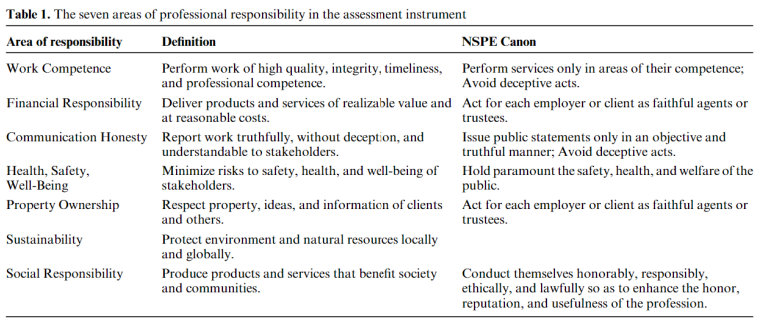

## Areas of Responsibility

The following is based on the IEEE code of ethics, available at the following link: <https://www.ieee.org/about/corporate/governance/p7-8.html>

| Area of Responsibility | IEEE-Specific Code of Ethics | Reasoning |
| --- | --- | --- |
| Work Competence | 1.6: to maintain and improve our technical competence and to undertake technological tasks for others only if qualified by training or experience, or after full disclosure of pertinent limitations; | This section of the IEEE code of ethics describes ways in which to make sure that engineers only take on work in terms of their competence. It is fairly consistent with its counterpart in the NSPE Canon. |
| Financial Responsibility | 1.4: to avoid unlawful conduct in professional activities, and to reject bribery in all its forms; | This section of the IEEE code of ethics differs from that of the NSPE Canon in its realization - financial responsibility, in the canon of the IEEE code of ethics, is closer to that of social responsibility. |
| Communication Honesty | 1.5: to seek, accept, and offer honest criticism of technical work, to acknowledge and correct errors, to be honest and realistic in stating claims or estimates based on available data, and to credit properly the contributions of others; | This section of the IEEE code of ethics is very similar to that of the NSPE canon in its latter half, but does expand upon communication with coworkers as well. It establishes the ways in which an engineer should strive to communicate with their coworkers |
| Health, Safety, Well-Being | 1.1: to hold paramount the safety, health, and welfare of the public, to strive to comply with ethical design and sustainable development practices, to protect the privacy of others, and to disclose promptly factors that might endanger the public or the environment; | This section of the IEEE code of ethics describes ways in which the engineer should strive to support both the public and their fellow man, and is consistent with that of the NSPE Canon. |
| Property Ownership | 1.5: to seek, accept, and offer honest criticism of technical work, to acknowledge and correct errors, to be honest and realistic in stating claims or estimates based on available data, and to credit properly the contributions of others; | This section of the IEEE code of ethics is fairly consistent with that of the NSPE Canon in its final line, and additionally describes ways in which the engineer should strive to make claims as well as criticism, compounding it with that of Communication Honesty. |
| Sustainability | 1.1: to hold paramount the safety, health, and welfare of the public, to strive to comply with ethical design and sustainable development practices, to protect the privacy of others, and to disclose promptly factors that might endanger the public or the environment; | This section of the IEEE code of ethics is not present in the NSPE canon, and thus cannot be compared. It describes in great detail the efforts an engineer should take in regards to how they approach the matter of public welfare. |
| Social Responsibility | 1.10: to support colleagues and co-workers in following this code of ethics, to strive to ensure the code is upheld, and to not retaliate against individuals reporting a violation. | This section of the IEEE code of ethics is fairly consistent with that of the NSPE Canon, with no major deviations. It implores all engineers to best service the larger community with as much support as they can muster. |

## 7.2 Project Specific Professional Responsibility Areas

| Area of Responsibility | Team Performance | Reasoning |
| --- | --- | --- |
| Work Competence | High | As this is a multidisciplinary project, we made sure to best divide the work up by available members and resources based on what they were most comfortable - and confident in - tackling. |
| Financial Responsibility | High | This project is fairly low cost, but we have taken great efforts to make sure that all financial matters related to this project are well documented and approved by all applicable parties. |
| Communication Honesty | High | We do our best to meet three times a week - twice as a team, the third with our faculty advisor to make sure that, at all times, our mentors and colleagues are aware of the current status of the project. |
| Health, Safety, Well-Being | High | We take appropriate safety precautions to make sure that there is no risk of injury at any point within this project, from grounding straps to training on how to use oscilloscopes and other electronic equipment for non-EE majors. |
| Property Ownership | High | As this project builds on those that came before, we are fastidious with the documentation of sources that we use throughout its creation. |
| Sustainability | Low | This project could not be described as ‘good for the environment’ or developed with sustainability in mind. |
| Social Responsibility | High | Our product benefits the community that would see the most use from it - audiophiles! We also make sure to interview potential users for product and market fit to make sure it best appeals to them. Additionally, we conduct ourselves as ethically as we can, and pride ourselves on our open and honest communication. |

## 

## 7.3 Most Applicable Professional Responsibility Area

The most applicable area of responsibility to our team is that of work competence. As this is a multidisciplinary project, we made sure to best divide the work up by available members and resources based on what they were most comfortable - and confident in - tackling. At all times, we communicate with our team members about what needs to be done and divide responsibilities up depending on applicable skill sets through honest and open communication. We would thus agree that the professional responsibility area most applicable to our project is that of work competence.

# 8 Closing Material

## 8.1 Discussion

Discuss the main results of your project – for a product, discuss if the requirements are met, for experiments oriented project – what are the results of the experiment, if you were validating a hypothesis – did it work?

In this project, we have successfully been able to create a program that can emulate a tube amp, and play any high order function we put into it over the input. Going forward we still have to create the product, but so far we have been able to successfully create the framework for our final project to work, and next semester all we have to do is follow our plan out and we will have a successful final product. With our current progress we are able to meet the initial guidelines of emulating a tube amp, but we are only missing the requirements of processing it in real time, and having a physical product.

## 8.2 Conclusion

Summarize the work you have done so far. Briefly re-iterate your goals. Then, re-iterate the best plan of action (or solution) to achieving your goals. What constrained you from achieving these goals (if something did)? What could be done differently in a future design/implementation iteration to achieve these goals?

This semester we have spent a lot of time researching approaches to complete this project, running tests on a tube amp to see how one behaved live, creating a program to run any audio input through a high order function and choosing a microcontroller that could successfully implement this best, and also creating a design plan to end up with a finished product at the end of next semester.

## 8.3 References

J. Pakarinen and M. Karjalainen, "Enhanced Wave Digital Triode Model for Real-Time Tube Amplifier Emulation," in IEEE Transactions on Audio, Speech, and Language Processing, vol. 18, no. 4, pp. 738-746, May 2010, doi: 10.1109/TASL.2009.2033306.

E. -P. Damskägg, L. Juvela, E. Thuillier and V. Välimäki, "Deep Learning for Tube Amplifier Emulation," ICASSP 2019 - 2019 IEEE International Conference on Acoustics, Speech and Signal Processing (ICASSP), Brighton, UK, 2019, pp. 471-475, doi: 10.1109/ICASSP.2019.8682805.

Normann, P. (2013). Design of amplifiers in LTspice: Aspects on the usage of spice-ware in thework of designing an electron tube amplifier.

## 8.4 Appendices

### Research on Methods of Tube Amp Emulation & Commercially Available

**What you have to emulate in a tube amp.**

* Triode
  + Anode -> Grid -> Cathode
    - In a triode the amplification is obtained by inducing and controlling an electric field between the anode and the cathode
      * You control this by changing grid bias, giving the grid more positive bias leaves to more plate bias (anode side)
      * Eventually the grid does saturate if too high, and if too low no current goes from cathode to anode.
      * Now that you can control the current on the anode side, you hook up a power transformer the other side and effectively have an amplifier that doesn’t really change the output signal.
      * The cathode is heated to lower the threshold for the cathode to emit electrons. Electrons are prone to stream from the negative cathode to the positive anode. The electric stream from the cathode to the anode in the triode induces a current. By controlling the electric field the current through the triode is indirectly controlled. The control mechanism is achieved by applying a negative voltage at the gird between the anode and the cathode.
* Pentode
  + Anode -> Control Grid -> Screen Grid -> Suppressor Grid -> Cathode
    - Control grid: functions like the grid in the triode.
    - Screen grid: focus the electron beam so that more of the jumping electrons make it to the anode.
    - Suppressor grid: hinders electrons to jump back to the screen grid
* Benefits of each
  + Triode
    - Due to the randomized division of the cathode flow across the screening array and the anode, pentodes exhibit increased distortion (partitioning sound).
    - Pentode
    - Fluctuations in Supply Voltage do not matter as much compared to a triode
    - Because of the screening action of the additional grid, pentodes (and tetrodes) have substantially less feedback impedance.
* **General Approaches to all Methods**
  + White Box
    - This approach derives the full third-order transfer function with no approximations for the filter by symbolic circuit analysis. Because the coefficients are described as algebraic functions of the parameters, this method is fully parametric.
    - This method doesn’t produce 100% accurate results as generally assumes everything works perfectly and not always rooted in reality.
  + Grey Box
    - Uses Math to try and emulate a tube amp 100%, and then uses real data afterwards to try and edit the output to line up to reality
    - In general uses white box method and black box method right after
  + Black Box
    - In summary, black-box approaches decide on a particular filter structure, and then they decide on coefficients for that structure to match the response of the target system. Ad hoc mappings from parameter space to coefficient space parameterize the filter
    - You look at the input and output of a signal and try to emulate the input to output through approximations such as a look-up table or waveshaping.

**Non linear Methods for Emulating a Tube Amp**

1. Waveshaping
   1. This is the easiest way to emulate a tube amp and the theory is to apply an instantaneous nonlinear mapping from the input variable to the output variable.
      1. Early formula developed by Yamaha (19790) is



* + - 1. In this formula the input has to be bounded between 1 & -1
    1. Doidicet formula



1. Look-up Table
   1. Kramer (1991)
   2. In this method, the system reads the input-output relation from a pre-stored table
2. Oversampling (TubeTone Modeling)
   1. Line 6 Company (Late 1990’s)
   2. Nonlinear signal processing blocks are known to expand the bandwidth of the incoming signal, which in a DSP system can cause aliasing if the bandwidth of the output exceeds the Nyquist frequency (i.e., half the sampling rate). An amplifier model can distort harmonic signals such as a guitar tone and produce many new harmonics in the output that, through aliasing into the audio range, are no longer harmonically related to the original tone. (A Review of Digital Techniques for Modeling Vacuum-Tube Guitar Amplifiers)
   3. In general if you oversamplify a signal and then amplify that signal in a digital signal processor, before sampling it at the Nyquist frequency again, you will have some more new harmonics that you didn’t have before.
3. Customized Waveshaping
   1. Fernández-Cid and Quirós (2001)
   2. An extension of waveshaping, you use a filterbank to separate your input signal into a bunch of different frequency signals, you than apply a unique nonlinear mapping to each of you different frequency signals.
4. Gustafasson (2004)
   1. In general, the theory is that a circuit looks at a signal for the last few milliseconds and depending on if the input signal is decreasing or increasing, he will then use a lookup table to decide the output. This method can also be used with customized waveshaping where know the output depends on the frequency, and its recent history.

### 8.4.1 Team Contract

Team Members:

1) Jack Cassidy 2) Ian Bixler

3) Harry Burnick 4) Ben Mullin

5) Julia Kroeper 6) Bradley McClellan

**Team Procedures**

1. *Day, time, and location (face-to-face or virtual) for regular team meetings:* Meetings weekly, on Mondays at 11 am. In the Transformation Learning Area.
2. *Preferred method of communication updates, reminders, issues, and scheduling (e.g., e-mail, phone, app, face-to-face):* Face to Face meetings preferred for design, and Discord for any other communications.
3. *Decision-making policy (e.g., consensus, majority vote):* Majority vote
4. *Procedures for record keeping (i.e., who will keep meeting minutes, how will minutes be shared/archived):* One person is assigned to take basic notes on meeting procedure and decisions made.

**Participation Expectations**

1. *Expected individual attendance, punctuality, and participation at all team meetings:* Punctuality to all meetings is expected, but excused absences will be permitted if circumstances require.
2. *Expected level of responsibility for fulfilling team assignments, timelines, and deadlines:* High expectations for fulfilling assignments, with strict adherence to deadlines.
3. *Expected level of communication with other team members:* Teammates are expected to communicate to one another readily.
4. *Expected level of commitment to team decisions and tasks:* High level of commitment to the project group, with all teammates participating in the decision making process and all assigned tasks.

**Leadership**

1. *Leadership roles for each team member (e.g., team organization, client interaction, individual component design, testing, etc.):* - Git Manager, Team Lead, Secretary, Client Interaction, Treasurer
2. *Strategies for supporting and guiding the work of all team members:* Consistent communications between teammates, along with organization of members and materials as they relate to each task.
3. *Strategies for recognizing the contributions of all team members:* Detailed documentation of each task along with notes on team member’s responsibilities.

**Collaboration and Inclusion**

1. *Describe the skills, expertise, and unique perspectives each team member brings to the team.*

Write a sentence or two about yourself and what you bring to the team.

**Benjamin Mullin:** I am a CYB E major with a minor in Music Technology. I have experience with logic circuit design, although my strong suit is more on the programming side of things. As part of my minor, I’ve done some work with audio processing and controlling instruments with MIDI.

**Bradley McClellan:** I am a SE major who has taken many CprE courses. I have experience with many low level languages, FPGA programming, Harnessing, etc. I work as an Audio Engineer for the Music Department here at Iowa State, and I love working with Synths and related audio equipment.

**Theodore Burnick:** In Electrical Engineering, I have completed much work with filters and signal processing both as a part of my education, but also in my work as Chief Engineer of Iowa State’s Radio Station, KURE. This job has given me much experience in both Broadcast Engineering and Audio Processing/Mixing that should prove useful during this project. My job also gives me access to many musicians and artist that may be willing to act as testers later on in the development process.

**Julia Kroeper:** As an EE, I’ve worked in the past extensively on FPGA circuits and Altium layout, but from a personal perspective, I work full-time as a creative director for various convention and virtual reality spaces and as such am confident in my ability to ideate and execute on a variety of projects.

**Ian Bixler:** I am en Electrical Engineer and know more about the power side of the the degree. While this doesn’t mix great with this project, I have taken Signals and Systems 1 and 2, which should be able to help a lot when it comes to creating a new audio sound effect.

**Jack Cassidy:** As a CprE, I’ve worked a lot with both hardware and software so I can bridge the gap between both of them to make it easier. I have a lot of experience with microcontrollers and building a lot of testing applications with them. I also have a lot of experience with Git and Gitlab so I use the skills that I had from that and we are doing the development of stuff correctly.

1. *Strategies for encouraging and support contributions and ideas from all team members:*

Our team will encourage and support contributions by praising accomplishments and offering the weekly meeting space as a discussion floor where we’re able to determine the progress of each aspect of the project and identify potential improvements in each area.

1. *Procedures for identifying and resolving collaboration or inclusion issues (e.g., how will a team member inform the team that the team environment is obstructing their opportunity or ability to contribute?)*
2. Establish that a problem exists and bring it to the attention of the team lead
3. Discuss the problem and ideate on potential solutions with the team lead
4. Team lead will set the problem as something open to discussion in the next weekly meeting
5. Work with team members to find a solution that works best for all members as agreed to by a majority vote

**Goal-Setting, Planning, and Execution**

1. *Team goals for this semester:*

Meet with the client to accurately set expectations, figure out the scope of the project, come up with initial design details as well as budget, and concisely distribute an adequate amount of work per member as well as a fitting role in preparation for building and testing the project next semester.

1. *Strategies for planning and assigning individual and team work:*

Assign each member achievable tasks within or within range of their skillset - as tasks may be collaborative, assign multiple members depending on the scope of work required.

1. *Strategies for keeping on task:*

Weekly meetings will keep the team accountable, as each member will be expected to report on their progress towards each task assigned to them as well as discuss whether or not they need more help to accomplish a specific task.

**Consequences for Not Adhering to Team Contract**

1. *How will you handle infractions of any of the obligations of this team contract?*

We will discuss infractions as a team and attempt to resolve the issue with the offending member as a collective.

1. *What will your team do if the infractions continue?*

Our team will talk to the TA or project lead in order to determine what the best course of action will be moving forward.

***************************************************************************

a) *I participated in formulating the standards, roles, and procedures as stated in this contract.*

b) *I understand that I am obligated to abide by these terms and conditions.*

c) *I understand that if I do not abide by these terms and conditions, I will suffer the*

*consequences as stated in this contract.*

1) Bradley McClellan DATE 9/7/2023

2) Theodore Burnick DATE 9/7/2023

3) Julia Kroeper DATE 9/7/2023

4) Benjamin Mullin DATE 9/10/2023

5) Ian Bixler DATE 9/10/2023

6) Jack Cassidy DATE 9/7/2023